leqcia 2
1.2. funqciis grafikis ageba
funqciis grafikis agebis diferencialuri meTodi Sedgeba Semdegi 9 nabijisgan:
1. funqciis gansazRvris aris povna; luw-kentobis da periodulobis dadgena;
2. wyvetis wertilebis povna; wyvetis wertilebSi calmxrivi zRvrebis gamoTvla;
3. sakoordinato RerZebTan TanakveTis wertilebis povna;
4. usasrulobaSi funqciis yofaqcevis Seswavla;
5. zrdadobisa da klebadobis intervalebis povna;
6. funqciis gamokvleva eqstremumze;
7. funqciis zemoT amozneqilobis, qvemoT amozneqilobis Sualedebis dadgena; gadaRunvis wertilebis povna;
8. funqciis asimptotebis povna;
9. pirveli rva punqtis gamoyenebiT grafikis ageba.

meTodis ilustrireba movaxdinoT Semdegi oTxi martivi funqciis magaliTze:
a) $y=x$; (1.2.1)
b) $y=\frac{1}{x}$; (1.2.2)
g) $y=x^{2}$; (1.2.3)
d) $y=\text{sin}x$. (1.2.4)

1. movZebnoT (1.2.1), (1.2.2), (1.2.3), (1.2.4) funqciebis gansazRvris areebi.
a) $y=x$ funqciis gansazRvris area $x∈]−∞;+∞[$, an, rac igivea, $x∈R^{1}$.
b) $y=\frac{1}{x}$ funqcia gansazRvrulia nebismieri wertilSi $R^{1}$-dan, garda 0-sa, e. i. $x∈]−∞;0[∪]0;+∞[$.
g) $y=x^{2}$ funqciis gansazRvris area $x∈]−∞;+∞[$.
d) $y=\text{sin}x$ funqciis gansazRvris area $x∈]−∞;+∞[$.
gavarkvioT TiToeuli funqciis luw-kentoba.

a) $f(x)=x$. ganvixiloT $f(−x)$.
$f(−x)=−x=−f(x)$, e. i. funqcia kentia.

b) $f(x)=\frac{1}{x}$. ganvixiloT
$f(−x)=\frac{1}{−x}=−\frac{1}{x}=−f(x)$, e. i. funqcia kentia.
g) $f(x)=x^{2}$. ganvixiloT
$f(−x)=(−x)^{2}=x^{2}=f(x)$, e. i. funqcia luwia.

d) $f(x)=\text{sin}x$. ganvixiloT
$f(−x)=\text{sin}(−x)$. (1.2.5)
nax. 1.2.1-ze mocemulia r-radiusiani wre. I meoTxedSi gadavzomoT $α$ radianis toli kuTxe. $\text{sin}α$-s ganmartebis Tanaxmad
O
nax. 1.2.1
$\text{sin}α=\frac{y}{r}$.
cxadia,
$\text{sin}(−α)=\frac{−y}{r}=−\frac{y}{r}=−\text{sin}α$.
bolo tolobis ZaliT, (1.2.5) toloba Semdegi saxiT gadaiwereba
$f(−x)=\text{sin}(−x)=−\text{sin}x=−f(x)$,
e. i. $y=\text{sin}x$ funqcia kentia.
SeniSvna 1.2.1. $y=\text{sin}x$ funqcia I da II meoTxedebSi dadebiT mniSvnelobebs iRebs, xolo III da IV meoTxedebSi _ uaryofiTs.
perioduloba.
a) $f(x)=x$.
$f(x+l)=x+l=x$ maSin da mxolod maSin, roca $l=0$, rac imas niSnavs, rom (1.2.1) funqcia ar aris perioduli.
b) $f(x)=\frac{1}{x}$.
$f(x+l)=\frac{1}{x+l}=\frac{1}{x}$ maSin da mxolod maSin, roca $l=0$, rac imas niSnavs, rom (1.2.2) funqciac araperiodulia.
g) analogiurad mtkicdeba, rom (1.2.3) funqciac araperiodulia. marTlac,
$f(x+l)=(x+l)^{2}=x^{2},$ $x^{2}+2\text{lx}+l^{2}=x^{2},$ $l(2x+l)=0\text{.}$ magram es ukanaskneli Sesruldeba maSin da mxolod maSin, roca $x=−\frac{l}{2}$ da ara nebismieri namdvili $x$-isaTvis.
d) (1.2.4) funqcia periodulia da misi umciresi dadebiTi periodia $2π$. marTlac, radgan
$\text{sin}(2π+x)=\text{sin}2π\text{cos}x+\text{cos}2π\text{sin}x=\text{sin}x$,
amitom $2π$ warmoadgens erT-erT periods, rac nax. 1.2.1-danac cxadia. vaCvenoT, rom is umciresi dadebiTi periodia. Tu davuSvebT, rom $0<l<2π$ periodia, maSin
$$\text{sin}(x+l)=\text{sin}x$$
nebismieri x-sTvis, maT Soris $x=0$-sTvisac. es imas niSnavs, rom
$\text{sin}l=\text{sin}0=0$,
rac marTebulia $2π$-ze naklebi mxolod erTi $l=π$ mniSvnelobisTvis. magram $π$ ar warmoadgens $\text{sin}x$-is periods, radgan $\text{sin}\frac{π}{2}=1$, $\text{sin}\left(\frac{π}{2}+π\right)=−1$.

2. gavarkvioT funqciis wyvetis wertilebis sakiTxi.
a) $y=x$ funqcias wyvetis wertilebi ar gaaCnia.
b) $y=\frac{1}{x}$ funqciis wyvetis wertilia $x=0$. vipovoT (1.2.2) funqciis calmxrivi zRvrebi wyvetis wertilSi
$\underset{x→0+}{\text{lim}}\frac{1}{x}\text{=+}∞$, $\underset{x→0−}{\text{lim}}\frac{1}{x}=−∞$.
(1.2.3) da (1.2.4) funqciebs wyvetis wertilebi ar gaaCnia.
3. funqciis grafikis x da y RerZebTan TanakveTis wertilebis mosaZebnad Sesabamisad y da x cvladebi unda gavutoloT nuls.
a) $y=x$ funqcia gadis koordinatTa saTaveze, e. i. (0,0) wertilze.
b) $y=\frac{1}{x}$ funqciis grafiki ar kveTs sakoordinato RerZebs.
g) $y=x^{2}$ funqciis grafiki gadis (0,0) wertilze.
d) $y=\text{sin}x$ funqciis grafiki x RerZs kveTs, roca $\text{sin}x=0$, e. i. $x=kπ$, $k=0, ±1, ±2,…$ wertilebSi, y RerZs ki _ (0,0) wertilSi, radgan $y=\text{sin}0=0$.

4. funqciis yofaqceva usasrulobaSi.
a) $\underset{x→±∞}{\text{lim}}x=±∞$.
b) $\underset{x→±∞}{\text{lim}}\frac{1}{x}=0$.
g) $\underset{x→±∞}{\text{lim}}x^{2}\text{=+}∞$.
d) $\underset{x→±∞}{\text{lim}}(\text{sin}x)$ ar arsebobs.

5. zrdadoba-klebadobis sakiTxis dadgena.
a) $f(x)=x$.
$f'(x)=1>0$, e. i. funqcia zrdadia gansazRvris mTel areze.
b) $f(x)=\frac{1}{x}$.
$f'(x)={\left(x^{−1}\right)}^{′}=(−1)x^{−2}=−\frac{1}{x^{2}}<0$ nebismieri $x≠0$-sTvis. funqcia klebadia Tavis gansazRvris areze.
g) $f(x)=x^{2}$.
$$f'(x)={\left(x^{2}\right)}^{′}=2xalignl\begin{aligned}\left\{0,\text{ roca }x>0,\text{ e}\text{.}\text{ i}\text{.}\text{ zrdadia, roca }x∈[0;+∞[, | \right.\end{aligned}$$
d) $f(x)=\text{sin}x$.
$$f'(x)=\text{cos}xalignl\begin{aligned}\left\{0,\text{ I da IV meoTxedebSi, e}\text{.}\text{ i}\text{.}\text{ iq zrdadia,} | \right.\end{aligned}$$

6. funqciis eqstremumis wertilebis moZebna.
a) $f(x)=x$.
$f'(x)=1≠0$, e. i. $y=x$ funqcias eqstremumis wertilebi ar aqvs.
b) $f(x)=\frac{1}{x}$.
$f'(x)=−\frac{1}{x^{2}}≠0$, e. i. $y=\frac{1}{x}$ funqcias eqstremumis wertilebi ar aqvs.
g) $f(x)=x^{2}$.
$f'(x)=2x=0$, roca $x=0$.
$x=0$ eqstremumis wertilia. imis gasarkvevad, es wertili maqsimumis wertilia Tu minimumis, saWiroa, vipovoT $f\text{ \backslash ( x \backslash ) \} \{}$:
$f\text{ \backslash ( x \backslash ) =2>0\} \{}$,
e. i. $x=0$ minimumis wertilia.
d) $f(x)=\text{sin}x$.
$f'(x)=\text{cos}x=0$, roca $x=\frac{π}{2}+πk$, $k=0; ±1; ±2;…$.
ganvixiloT $f\text{ \backslash ( x \backslash ) \} \{}$:
$f\text{ \backslash ( x \backslash ) = - }sin\text{x drarrow f}\left(\frac{π}{2}+πk\right)=−\text{sin}\left(\frac{π}{2}+πk\right)=−\text{cos}πkalignl\begin{aligned}\left\{0,\text{ roca }k=2j, | \right.\end{aligned}$$j=0; ±1; ±2;$....
miviReT, rom $x=\frac{π}{2}+2πj$, $j=0, ±1, ±2$,$…$ funqciis maqsimumis $\left[\text{sin}\left(\frac{π}{2}+2πj\right)=1\right]$ wertilebia, xolo $x=\frac{π}{2}+π(2j+1)$*), e. i. $x=−\frac{π}{2}+2πj$,^{*)} $j=0$, $±1$, $±2$,$…$, funqciis minimumis $\left[\text{sin}\left(−\frac{π}{2}+2πj\right)=−1\right]$ wertilebia.

7. funqciis zemoT amozneqiloba, qvemoT amozneqiloba; gadaRunvis wertilebis povna.
a) $f(x)=x$.
$f\text{ \backslash ( x \backslash ) =0\} \{}$, e. i. $y=x$ funqcia ar aris arc zemoT amozneqili da arc qvemoT amozneqili.
b) $f(x)=\frac{1}{x}$.
$$f\text{ \backslash ( x \backslash ) = left ( \{ \{1\} over \{x\} \} right ) rSup \{ size 8\{}={\left(−x^{−2}\right)}^{'}=\frac{2}{x^{3}}\begin{aligned}\left\{0,\text{ roca }x>0, | \right.\end{aligned}$$
e. i. $y=\frac{1}{x}$ funqciis grafiki $x∈]0;+∞[$ SualedSi qvemoT amozneqilia, xolo $x∈]−∞;0[$ SualedSi _ zemoT amozneqili.
g) $f(x)=x^{2}$.
$f\text{=2>0\} \{}$, e. i. funqciis grafiki qvemoT amozneqilia.
d) $f(x)=\text{sin}x$.
$$f\text{ \backslash ( x \backslash ) = - }sin\text{xalignl \{ stack \{ left lbrace >0,}IIIdaIVmeoTxedebSi,\text{ \{\} \# right none left lbrace <0,}IdaIImeoTxedebSi,\text{ \{\} \# right no \} \} lbrace \} \{}$$
e. i. funqciis grafiki qvemoT amozneqilia, roca $x∈]−π+2πk,2πk[$, zemoT amozneqilia, roca $x∈]2πk,π(1+2k)[$, $k=0; ±1; ±2; ⋯$. cxadia, rom
$f\text{ \backslash ( πk \backslash ) = - }sin\text{ \backslash ( πk \backslash ) =0\} \{}$,
rac imas niSnavs, rom $x=πk$ gadaRunvis wertilebia.
gamovTvaloT gadaRunvis $0$ da $π$ wertilebSi gavlebul mxebTa mier $x$ RerZTan Sedgenili kuTxeebi. wirisadmi gavlebuli mxebis gantolebis formulidan Sesabamisad gveqneba
$y−\text{sin} 0=\text{sin'} 0 ⋅ (x−0)$ da $y−\text{sin} π=\text{sin'} π ⋅ (x−π)$,
e.i.
$y=\text{cos} 0 ⋅x$ da $y=\text{cos} π ⋅(x−π)$.
saidanac $y=x$ da $y=−x+π$. magram, radgan sakuTxo koeficienti $\text{tg}α=m=f'(x_{0})$, amitom $\text{tg}α=1$, roca $x_{0}=0$, da $\text{tg}α=−1$, roca $x_{0}=π$. Sesabamisad $α=\frac{π}{4}$, roca $x_{0}=0$, da $α=−\frac{π}{4}$ an rac igivea $α=\frac{3π}{4}$, roca $x_{0}=π$.

8. asimptotebis povna.
a) (1.2.1) funqciis grafiks asimptotebi ar aqvs. marTlac,
$$k=\underset{x→±∞}{\text{lim}}\frac{f(x)}{x}=\underset{x→±∞}{\text{lim}}\frac{x}{x}=\underset{x→±∞}{\text{lim}}1=1;$$
$$b=\underset{x→±∞}{\text{lim}}[f(x)−\text{kx}]=\underset{x→±∞}{\text{lim}}(x−x)=0\text{.}$$
kvlav miviReT $y=x$ funqcia, romlis asimptotasac veZebT. magram asimptota ar SeiZleba grafiks kveTdes (roca wiris wertili usasrulobaSi miiswrafis), miT ufro emTxveodes.
b) (1.2.2) funqciis grafikis horizontaluri asimptotaa $y=0$, vertikaluri asimptota ki _ $x=0$; daxrili asimptotebi ar gaaCnia. marTlac,
$$k=\underset{x→±∞}{\text{lim}}\frac{f(x)}{x}=\underset{x→±∞}{\text{lim}}\frac{\frac{1}{x}}{x}=\underset{x→±∞}{\text{lim}}\frac{1}{x^{2}}=0;$$
$$b=\underset{x→±∞}{\text{lim}}[f(x)−\text{kx}]=\underset{x→±∞}{\text{lim}}\frac{1}{x}=0\text{.}$$
amrigad, asimptotaa $y=0⋅x+0=0\text{.}$ es ukanaskneli ki horizontaluri asimptotaa. radgan $\underset{x→0+}{\text{lim}}f(x)=\underset{x→0+}{\text{lim}} \frac{1}{x}\text{=+}∞$ da $\underset{x→0−}{\text{lim}}f(x)=\underset{x→−}{\text{lim}} \frac{1}{x}=−∞$, amitom $x=0$-s, e.i., $y$ RerZi vertikaluri asimptotaa.
g) (1.2.3) funqciis grafiks asimptotebi ar aqvs. marTlac,
$$k=\underset{x→±∞}{\text{lim}}\frac{f(x)}{x}=\underset{x→±∞}{\text{lim}}\frac{x^{2}}{x}=\underset{x→±∞}{\text{lim}}x=±∞\text{.}$$
radgan $k$ sasruli unda iyos, daxrili da horizontaluri asimptotebi ar arsebobs. vinaidan $y=x^{2}$ funqcia mTel RerZzea gansazRvruli, arc vertikaluri asimptota ar arsebobs.
d) (1.2.4) funqciis grafiks asimptotebi ar aqvs. marTlac,
$$k=\underset{x→±∞}{\text{lim}}\frac{f(x)}{x}=\underset{x→±∞}{\text{lim}}\frac{\text{sin} x}{x}=0;$$
$$b=\underset{x→±∞}{\text{lim}}[f(x)−\text{kx}]=\underset{x→±∞}{\text{lim}}(\text{sin} x−0⋅x)=\underset{x→±∞}{\text{lim}} \text{sin} x$$
es ukanaskneli ki ar arsebobs. amrigad, daxrili da horizontaluri asimptota ar arsebobs. radgan $\text{sin} x$ mTel RerZzea gansazRvruli, amitom vertikaluri asimptotac ar arsebobs.

9. grafikis ageba (ix. nax. 1.2.2 _1.2.5).

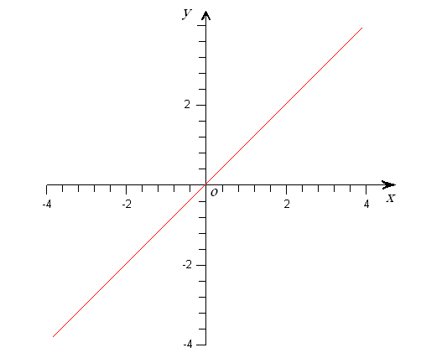
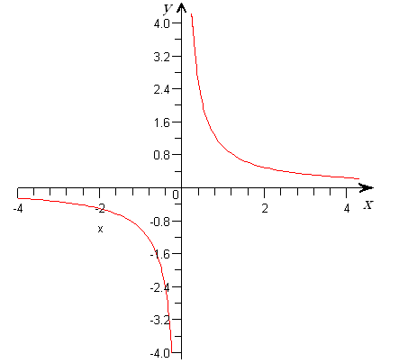
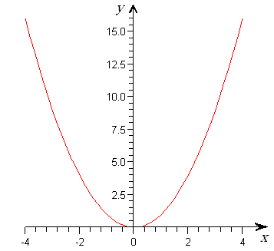
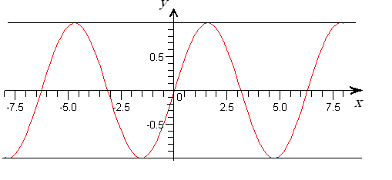
nax. 1.2.2
nax. 1.2.3
nax. 1.2.4
nax. 1.2.5

1.3. xarisxovani funqcia
gansazRvra 1.3.1.
$y=x^{n}$ (1.3.1)
saxis funqcias, sadac $n∈R$, xarisxovani funqcia ewodeba.
SeniSvna 1.3.2. cxadia, roca $n=0$, (1.3.1) funqcia $y=1$ saxes miiRebs da misi grafiki $x$ RerZis paraleluri wrfea. $n=1$ SemTxveva gamokvleuli gvaqvs 1.2 paragrafSi. amitom (1.3.1) funqciis gamokvlevisas vigulisxmebT, rom $n≠0, 1$.
ganvixiloT Semdegi 4 SemTxveva
I. $\left|n\right|=2k$, $k=1,2,3$, $…$.
II. $\left|n\right|=2k−1$, $k=2,3$, $…$ an $n=−1$.
III. $\left|n\right|=\frac{l}{k}$, sadac k da l urTierTmartivi naturaluri ricxvebia, amasTan k kenti ricxvia.*)
IV. $\left|n\right|=\frac{l}{k}$, sadac $k$ da $l$ urTierTmartivi naturaluri ricxvebia, amasTan $k$ luwi ricxvia.
SeviswavloT (1.3.1) funqciis Tvisebebi TiToeul SemTxvevaSi.

1. funqciis gansazRvris aris povna.
I, II da III SemTxvevaSi $x∈]−∞,+∞[$, roca $n>0$, da $x∈]−∞,0[∪]0,+∞[$, roca $n<0$.
IV SemTxvevaSi $x∈[0,+∞[$, roca $n>0$, da $x∈]0,+∞[$, roca $n<0$.

luw-kentobis sakiTxis dadgena.
I. $f(−x)=(−x)^{n}=\begin{aligned}\left\{(−x)^{2k}=(−1)^{2k}x^{2k}=x^{2k}=f(x), \text{roca} n>0, | \right.\end{aligned}$
e. i. funqcia luwia.
II. $f(−x)=(−x)^{n}=\begin{aligned}\left\{(−x)^{2k−1}=(−1)^{2k−1}x^{2k−1}=−x^{2k−1}=−f(x), \text{roca} n>0, | \right.\end{aligned}$
e. i. funqcia kentia.
III. dadebiTi n-ebisTvis gveqneba
$$f(−x)=(−x)^{\frac{l}{k}}=\begin{aligned}\left\{{\left[(−x)^{l}\right]}^{\frac{1}{k}}={\left[(−1)^{l}x^{l}\right]}^{\frac{1}{k}}={\left[x^{l}\right]}^{\frac{1}{k}}=x^{\frac{l}{k}}=f(x), | \right.\left\{\text{roca }l\text{ luwia, e}\text{.}\text{ i}\text{.}\text{ funqcia luwia,} | \right.\left\{{\left[(−x)^{l}\right]}^{\frac{1}{k}}={\left[(−1)^{l}x^{l}\right]}^{\frac{1}{k}}={\left[(−1)x^{l}\right]}^{\frac{1}{k}}=(−1)^{\frac{1}{k}}x^{\frac{l}{k}} | \right.\left\{−x^{−\frac{l}{k}}=−f(x),\text{ roca }l\text{ kentia, e}\text{.}\text{ i}\text{.} | \right.\end{aligned}$$
uaryofiTi n-ebisTvis ki analogiurad gveqneba
$$f(−x)=(−x)^{−\frac{l}{k}}=\begin{aligned}\left\{x^{−\frac{l}{k}}=f(x),\text{ roca }l\text{ luwia, e}\text{.}\text{ i}\text{.}\text{ funqcia luwia,} | \right.\end{aligned}$$
IV. am SemTxvevaSi funcia arc luwia da arc kenti, radgan gansazRvris are ar aris simetriuli koordinatTa saTavis mimarT.
xarisxovani funqcia ar aris perioduli funqcia.
SeniSvna 1.3.3. radgan luwi funqciis grafiki simetriulia $y$ RerZis mimarT, xolo kenti funqciis grafiki simetriulia koordinatTa saTavis mimarT, simartivisTvis (1.3.1) funqciis monotonurobis Sualedebs da Cazneqiloba-amozneqilobis sakiTxebs SeviswavliT dadebiTi $x$-ebisTvis (uaryofiTi $x<0$-sTvis SegviZlia simetriuloba gamoviyenoT).

2. funqciis wyvetis wertilebis povna.
(1.3.1) funqcias wyvetis wertilebi SeiZleba hqondes mxolod maSin, roca $n<0$.
I. $\underset{x→0+}{\text{lim}}x^{−2k}\text{=+}∞$, $\underset{x→0−}{\text{lim}}x^{−2k}\text{=+}∞$.
II. $\underset{x→0+}{\text{lim}}x^{−(2k−1)}\text{=+}∞$, $\underset{x→0−}{\text{lim}}x^{−(2k−1)}=−∞$.
III. $\underset{x→0+}{l\text{im}}x^{{−l}/k}\text{=+}∞$, $\underset{x→0−}{\text{lim}}x^{{−l}/k}=\begin{aligned}\left\{+∞, \text{roca }l\text{ luwia,} | \right.\end{aligned}$
IV. $\underset{x→0+}{\text{lim}}x^{{−l}/k}\text{=+}∞\text{.}$

3. RerZebTan TanakveTis wertilebis povna.
roca $n>0$, funqciis grafiki gadis koordinatTa saTaveze. uaryofiTi $n$-sTvis funqciis grafiki ar kveTs arc $x$ da arc $y$ RerZs.

4. yofaqceva usasrulobaSi.
I.$\begin{aligned}\underset{x→±∞}{\text{lim}}x^{n}=\underset{x→±∞}{\text{lim}}x^{±2k}=\underset{x→±∞}{\text{lim}}{\left(±\left|x\right|\right)}^{±2k}=\underset{x→±∞}{\text{lim}}{\left(±1\right)}^{±2k}{\left|x\right|}^{±2k}=\underset{x→±∞}{\text{lim}}{\left|x\right|}^{±2k} \\ \\ \end{aligned}\begin{aligned}\left\{+∞,\text{ roca }n=2k>0, | \right.\end{aligned}$
II.$\begin{aligned}\underset{x→±∞}{\text{lim}}x^{n}=\underset{x→±∞}{\text{lim}}x^{±(2k−1)}=\underset{x→±∞}{\text{lim}}{\left(±\left|x\right|\right)}^{±(2k−1)}=\underset{x→±∞}{\text{lim}}{\left(±1\right)}^{±(2k−1)}{\left|x\right|}^{±(2k−1)} \\ \\ \end{aligned}\begin{aligned}\left\{±∞,\text{ roca }n=2k−1>0, | \right.\end{aligned}$
III. $\underset{x→+∞}{\text{lim}}x^{n}=\begin{aligned}\left\{+∞,\text{ roca }n>0, | \right.\end{aligned}$ $\underset{x→−∞}{\text{lim}}x^{n}=\begin{aligned}\left\{+∞,\text{ roca }n>0\text{ da }l\text{ luwia}, | \right.\left\{−∞,\text{ roca }n>0\text{ da }l\text{ kentia}, | \right.\end{aligned}$
IV. $\underset{x→+∞}{\text{lim}}x^{n}=\begin{aligned}\left\{+∞,\text{ roca }n>0, | \right.\end{aligned}$

5. monotonurobis Sualedebis dadgena.
xarisxovani funqciis warmoebuli
$y'={\text{nx}}^{n−1}$.
cxadia, dadebiTi $x$-ebisTvis $y'>0$, mxolod maSin, roca $n$ dadebiTia, e. i. funqcia $]0,+∞[$-SualedSi zrdadia nebismieri $n>0$-sTvis, xolo uaryofiTi $n$-ebisTvis funqcia klebadia (uaryofiTi $x$-ebisTvis zrdadoba-klebadobis sakiTxis dasadgenad gaviTvaliswinoT SeniSvna 1.3.3.).

6. eqstremumis wertilebis povna.
eqstremumis wertilebis mosaZebnad saWiroa iseTi wertilebis moZebna, sadac funqciis warmoebuli nuls udris. radgan $n≠0,1$, amitom
$$y'={\text{nx}}^{n−1}\begin{aligned}\left\{0,\text{ roca }n<1, | \right.\end{aligned}$$
miviReT, rom xarisxovan funqcias, roca $n<1$, eqstremumis wertili ar gaaCnia, xolo roca $n>1$, $x=0$ SeiZleba eqstremumis (minimumis an maqsimumis) wertili iyos.
radgan
$y\text{''}=n(n−1)x^{n−2}$,
I. $y\text{''}(0)>0$, roca $n=2$, e. i. $x=0$ minimumis wertilia, xolo roca $n=4,6,…$, maSin $y\text{''}(0)=0$ da damatebiTi gamokvlevaa saWiro (ix. qvemoT me-7 punqti).
II. $y\text{''}(0)=0$, radgan gansaxilvel SemTxvevaSi $n=3,5,…$, amitom damatebiTi gamokvlevaa saWiro (ix. qvemoT me-7 punqti).
III. Tu gamovricxavT $k=1$, $l=2$ SemTxvevas, radgan is I SemTxvevaSi ganvixileT, $y\text{ \backslash ( 0 \backslash ) \} \{}$ an nulia, an usasruloba da saWiro xdeba damatebiTi gamokvleva (ix. qvemoT me-7 punqti).
IV.$x=0$ funqciis minimumis wertilia dadebiTi n-ebisTvis.

7. funqciis qvemoT amozneqiloba - zemoT amozneqilobis sakiTxis dadgena.
I. $y\text{''}(x)=n(n−1)x^{n−2}>0$, roca $x≠0$, nebismieri $n$-sTvis ($|n|=2k$, $k=1,2,3,…$), rac imas niSnavs, rom funqciis grafiki qvemoT amozneqilia da amdenad, $x=0$ wertili minimumis wertilia, roca $n=4,6,…$, iseve rogorc $n=2$ SemTxvevaSi, romelic adre ganvixileT.
II. $y\text{''}(x)=n(n−1)x^{n−2}\begin{aligned}\left\{0, \text{roca} x>0, \text{funqciis} \text{grafiki qvemoT amozneqilia,} | \right.\end{aligned}$
amdenad, $x=0$ wertili funqciis gadaRunvis wertilia.
III. radgan
$$y\text{ \backslash ( x \backslash ) = \{ \{l\} over \{k\} \} left ( \{ \{l\} over \{k\} \} - 1 right )x rSup \{ size 8\{ \{ \{l\} over \{k\} \} - 2\} \} alignl \{ stack \{ left lbrace <0,```}roca\text{``` left ( \{ \{l\} over \{k\} \} >1,``l``}kentia\text{``}da\text{``x<0 right ),`` \{\} \# right none left lbrace }an\text{``` left ( \{ \{l\} over \{k\} \} <1,```x>0 right ),``}an\text{`` left ( \{ \{l\} over \{k\} \} <1,``l``}luwia\text{ right ); \{\} \# right none left lbrace >0,```}roca\text{``` left ( \{ \{l\} over \{k\} \} >1,``l``}luwia\text{ right ),`` \{\} \# right none left lbrace }an\text{``` left ( \{ \{l\} over \{k\} \} >1,```x>0 right ),``}an\text{`` left ( \{ \{l\} over \{k\} \} <1,``l```}kentia\text{``}da\text{``x<0 right ), \{\} \# right no \} \} lbrace \} \{}$$
$$\begin{aligned}\text{roca} \left(\frac{l}{k}>1, l \text{kentia} \text{da} x<0\right) , \text{an} \left(\frac{l}{k}<1, x>0\right) , \text{an} \left(\frac{l}{k}<1, l \text{luwia}\right), \\ \text{maSin} \text{funqciis} \text{grafiki} \text{zemoT amozneqilia, xolo} \\ \text{roca} \left(\frac{l}{k}>1, l \text{luwia}\right), \text{an} \left(\frac{l}{k}>1, x>0\right), \text{an} \left(\frac{l}{k}<1, l \text{kentia} \text{da} x<0\right) − \text{qvemoT amozneqilia}\text{.}\end{aligned}$$
IV. radgan am SemTxvevaSi $x>0$, amitom
$y\text{''}(x)=n(n−1)x^{n−2}\begin{aligned}\left\{0, \text{roca} n>1 \text{an} n<0, e\text{.}i\text{.}, \text{funqciis grafiki qvemoT amozneqilia;} | \right.\end{aligned}$.

8. asimptotebis povna.
radgan oTxive SemTxvevaSi (I-IV)
$\underset{x→0}{\text{lim}}x^{n}=±∞$, roca $n<0$,
amitom y RerZi $(x=0)$ vertikaluri asimptotaa.
vipovoT daxrili asimptota:
$$k=\underset{x→+∞}{\text{lim}}\frac{f(x)}{x}=\underset{x→+∞}{\text{lim}}\frac{x^{n}}{x}=\underset{x→+∞}{\text{lim}}x^{n−1}=\begin{aligned}\left\{+∞, \text{roca }n>1; | \right.\end{aligned}$$
$b=\underset{x→+∞}{\text{lim}}(f(x)−0x)=\underset{x→+∞}{\text{lim}}x^{n}=0$, roca $n<0$*).
amitom $y=0$ wrfe, e. i. x RerZi warmoadgens horizontalur asimptotas, roca $n<0$.
amrigad, uaryofiTi $n$-sTvis (1.3.1) funqciis asimptotebia $y=0$ da $x=0$.

9. funqciis grafikis ageba.
zemoT Catarebuli analizidan gamomdinare, sailustraciod moviyvanoT Semdegi grafikebi (ix. nax. 1.3.1 _ 1.3.8, agebulia kompiuteris gamoyenebiT).

I.
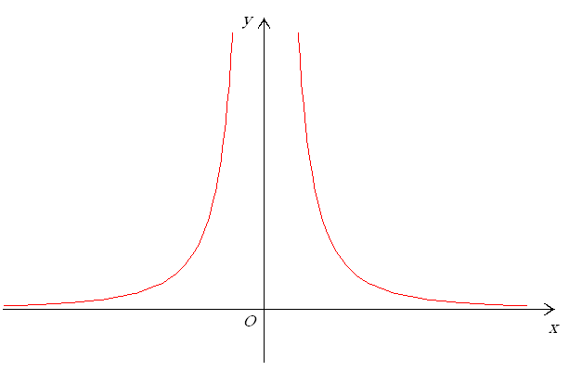
nax. 1.3.1 nax. 1.3.2

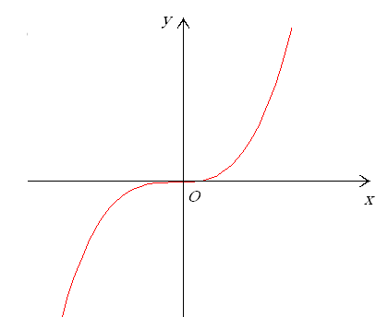
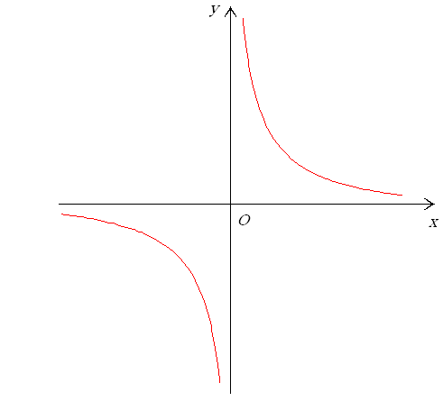
II.
nax. 1.3.3 nax. 1.3.4

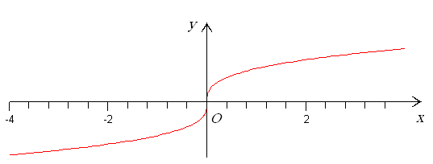
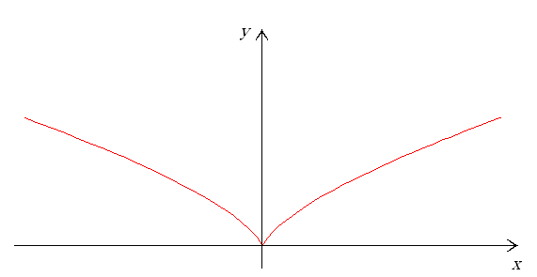
nax. 1.3.5
nax. 1.3.6
III.

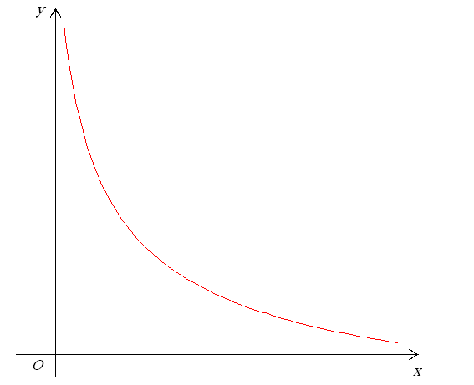
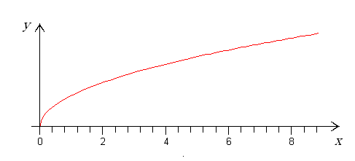
IV.
nax. 1.3.7
nax. 1.3.8

I SemTxvevaSi, roca $n=2k$ $(k=1,2,3,…)$, xarisxovani funqciis grafikis forma emTxveva nax. 1.3.1-ze moyvanili grafikis formas.
I SemTxvevaSi, roca $n=2k$ $(k=−1,−2−,3,…)$, xarisxovani funqciis grafikis forma emTxveva nax. 1.3.2-ze moyvanili grafikis formas.
II SemTxvevaSi, roca $n=2k+1$ $(k=1,2,3,…)$, xarisxovani funqciis grafikis forma emTxveva nax. 1.3.3-ze moyvanili grafikis formas.
II SemTxvevaSi, roca $n=−(2k+1)$ $(k=1,2,3,…)$, xarisxovani funqciis grafikis forma emTxveva nax. 1.3.4-ze moyvanili grafikis formas.
III SemTxvevaSi, roca l kentia da $n=\frac{l}{k}>1$, xarisxovani funqciis grafikis forma emTxveva nax. 1.3.3-ze moyvanili grafikis formas;
III SemTxvevaSi, roca l luwia da $n=\frac{l}{k}>1$, xarisxovani funqciis grafikis forma emTxveva nax. 1.3.1-ze moyvanili grafikis formas;
III SemTxvevaSi, roca $n<0$ da l kentia, xarisxovani funqciis grafikis forma emTxveva nax. 1.3.4-ze moyvanili grafikis formas;
III SemTxvevaSi, roca $n<0$ da l luwia, xarisxovani funqciis grafikis forma emTxveva nax. 1.3.2-ze moyvanili grafikis formas;
III SemTxvevaSi, roca l kentia da $0<\frac{l}{k}<1$, xarisxovani funqciis grafikis forma emTxveva nax. 1.3.5-ze moyvanili grafikis formas;
III SemTxvevaSi, roca l luwia da $0<\frac{l}{k}<1$, xarisxovani funqciis grafikis forma emTxveva nax. 1.3.6-ze moyvanili grafikis formas.
IV SemTxvevaSi, roca $n>1$, xarisxovani funqciis grafiks aqvs $y=x^{\frac{3}{2}}$ funqciis grafikis forma, xolo roca $0<n<1$, $y=x^{\frac{1}{2}}$ funqciis grafikis forma (ix. nax. 1.3.7).
IV SemTxvevaSi, roca $n<0$, xarisxovani funqciis grafikis forma emTxveva nax. 1.3.8-ze moyvanili grafikis formas.
1.4. maCvenebliani funqcia
gansazRvra 1.4.1.
$$y=a^{x}$$
saxis funqcias, sadac $a>0$, $a≠1$, maCvenebliani funqcia ewodeba.
SeviswavloT maCvenebliani funqciis Tvisebebi.

1. funqciis gansazRvris aris povna.
$y=a^{x}$ funqciis gansazRvris area $x∈]−∞,+∞[$.
gavarkvioT funqciis luw-kentobis sakiTxi. radgan
$$f(−x)=a^{−x}\begin{aligned}\left\{−f(x), | \right.\end{aligned}$$
amitom $f$ funqcia arc luwia da arc kenti.
funqciis periodulobis gasarkvevad l-is mimarT unda amovxsnaT
$$a^{x+l}=a^{x}$$
gantoleba. a fuZiT galogariTmebis Semdeg miviRebT
$x+l=x$.
cxadia, am gantolebas l–is mimarT nulisagan gansxvavebuli amonaxsni ar aqvs, e. i. funqcia araperiodulia.

2. funqciis wyvetis wertilebis povna.
funqcias wyvetis wertilebi ar aqvs.

3. RerZebTan TanakveTis wertilebis povna.
funqciis grafikis y RerZTan gadakveTis wertilis mosaZebnad vipovoT funqciis mniSvneloba $x=0$ wertilSi:
$f(0)=a^{0}=1$,
e. i. funqciis grafiki y RerZs kveTs $(0,1)$ wertilSi. funqciis grafiki x RerZs ar kveTs, marTlac, $a^{x}>0$ x-is nebismieri mniSvnelobisTvis.

4. yofaqceva usasrulobaSi.
$\underset{x→+∞}{\text{lim}}a^{x}=\begin{aligned}\left\{+∞,\text{ roca }a>1, | \right.\end{aligned}$ $\underset{x→−∞}{\text{lim}}a^{x}=\begin{aligned}\left\{0,\text{ roca }a>1, | \right.\end{aligned}$

5. zrdadoba-klebadobis sakiTxis garkveva.
$$y'(x)={\left(a^{x}\right)}^{′}=a^{x}\text{ln}aalignl\begin{aligned}\left\{0,\text{ roca }a>1, | \right.\end{aligned}$$
funqcia zrdadia, Tu $a>1$, klebadia, Tu $0<a<1$.

6. eqstremumis wertilebis povna.
funqcias eqstremumis wertilebi ar gaaCnia, radgan
$y'(x)=a^{x}\text{ln}a≠0$, roca $a≠1$.

7. funqciis qvemoT amozneqiloba - zemoT amozneqilobis sakiTxis dadgena.
davadginoT meore rigis warmoebulis niSnebi
$y \text{ \backslash ( x \backslash ) =a rSup \{ size 8\{x\} \} }ln\text{ rSup \{ size 8\{2\} \} a>0\} \{}$,
e. i. $y=a^{x}$ funqciis grafiki qvemoT amozneqilia.
8. asimptotebis povna.
maCveneblian funqcias vertikaluri asimptota ar aqvs, radgan is uwyvetia, roca $x∈R$. vipovoT daxrili asimptota, Tu aseTi arsebobs. ganvixiloT Semdegi zRvrebi:

a)
$$k=\underset{x→+∞}{\text{lim}}\frac{f(x)}{x}=\underset{x→+∞}{\text{lim}}\frac{a^{x}}{x}=\underset{x→+∞}{\text{lim}}\frac{a^{x}\text{ln}a}{1}=\begin{aligned}\left\{+∞,\text{ roca }a>1, | \right.\end{aligned}$$
e. i. roca $0<a<1$, funqcias aqvs horozontaluri asimptota $y=0$, radgan am SemTxvevaSi $k=0$ da
$b=\underset{x→+∞}{\text{lim}}\left(f(x)−\text{kx}\right)=\underset{x→+∞}{\text{lim}}f(x)=0$.

b)
$$\underset{x→−∞}{\text{lim}}\frac{f(x)}{x}=\underset{x→−∞}{\text{lim}}\frac{a^{x}\text{ln}a}{1}=\begin{aligned}\left\{0,\text{ roca }a>1, | \right.\end{aligned}$$
roca $a>1$, funqcias aqvs horozontaluri asimptota $y=0$, radgan am SemTxvevaSi $k=0$ da
$b=\underset{x→−∞}{\text{lim}}\left(f(x)−\text{kx}\right)=\underset{x→−∞}{\text{lim}}f(x)=0$.

9. funqciis grafikis ageba.
zemoT Catarebuli analizidan gamomdinare, grafikebs aqvT qvemoT moyvanili saxe (ix. nax. 1.4.1, 1.4.2, agebulia kompiuteris gamoyenebiT).

y
1
y
x
x
1
O
nax. 1.4.1 nax. 1.4.2

O
1.5. logariTmuli funqciebi
gansazRvra 1.5.1.
$y={\text{log}}_{a}x$ (1.5.1)
saxis funqcias, sadac $a>0$ da $a≠1$, ewodeba logariTmuli funqcia.
gansazRvra 1.5.2. x ricxvis logariTmi a fuZiT ewodeba iseT y ricxvs, romelSic unda avaxarisxoT a, rom miviRoT x, e. i. (1.5.1)-dan gamomdinareobs
$x=a^{y}$, $a>0$. (1.5.2)
SeniSvna 1.5.3. (1.5.2) da (1.5.1) urTierTSebrunebuli funqciebia.
SeviswavloT (1.5.1) funqciis Tvisebebi da avagoT misi grafiki.

1. funqciis gansazRvris area $x∈]0,+∞[$.
funqciis gansazRvris are ar aris simetriuli koordinatTa saTavis mimarT, amitom (1.5.1) arc luwia da arc kenti.
gavarkvioT periodulobis sakiTxi. ganvixiloT toloba
${\text{log}}_{a}(x+l)={\text{log}}_{a}x$.
cxadia, rom ukanaskneli toloba sruldeba mxolod maSin, roca $l=0$, e. i. funqcia araperiodulia. marTlac, potencirebiT miviRebT, rom $x+l=x$. aqedan ki gamomdinareobs, rom $l=0$.

2. yofaqceva wyvetis wertilebSi.
martivi saCvenebelia, rom
$$\underset{x→0+}{\text{lim}}{\text{log}}_{a}x=\begin{aligned}\left\{−∞,\text{ roca }a>1, | \right.\end{aligned}$$

3. RerZebTan TanakveTis wertilebis povna.
funqciis grafiki y RerZs ar kveTs, radgan funqcia $x=0$ wertilSi gansazRvruli ar aris.
x RerZTan TanakveTis wertilis mosaZebnad amovxsnaT gantoleba
${\text{log}}_{a}x=0⇒x=a^{0}=1$.
(1.5.1) funqciis grafiki x RerZs kveTs RerZis $x=1$ wertilSi.

4. yofaqceva usasrulobaSi.
SevniSnoT, rom funqcia gansazRvrulia $x∈]0,+∞[$ SualedSi, e. i. gansaxilveli gvaqvs mxolod zRvari, roca $x→+∞$,
$$\underset{x→+∞}{\text{lim}}{\text{log}}_{a}x=\begin{aligned}\left\{+∞,\text{ roca }a>1, | \right.\end{aligned}$$

5. zrdadoba-klebadobis sakiTxis dadgena.
vipovoT funqciis warmoebuli da davadginoT misi niSani.
$$({\text{log}}_{a}x) ' =\frac{1}{x\text{ln}a}\begin{aligned}\left\{0,\text{ roca }a>1, | \right.\end{aligned}$$
es ukanaskneli gamomdinareobs iqidan, rom $\text{ln}a>0$, roca $a>1$, da $\text{ln}a<0$, roca $0<a<1$. amitom, roca $a>1$, funqcia zrdadia, xolo, roca $0<a<1$, funqcia klebadia.

6. funqciis eqstremumis wertilebis povna.
eqstremumis wertilebis mosaZebnad funqciis warmoebuli unda gavutoloT nuls. radgan,
$({\text{log}}_{a}x) ' =\frac{1}{x\text{ln}a}≠0$,
amitom funqcias eqstremumis wertilebi ar aqvs.

7. funqciis zemoT amozneqilobis da qvemoT amozneqilobis Sualedebis mosaZebnad vipovoT funqciis meore rigis warmoebuli
$$y\text{= left ( \{ \{1\} over \{x}ln\text{a\} \} right ) rSup \{ size 8\{′\} \} = \{ \{1\} over \{}ln\text{a\} \} left (x rSup \{ size 8\{ - 1\} \} right ) rSup \{ size 8\{′\} \} = - \{ \{1\} over \{x rSup \{ size 8\{2\} \} }ln\text{a\} \} alignl \{ stack \{ left lbrace <0,}rocaln\text{a>0},e . i . roca\text{a>1, \{\} \# right none left lbrace >0,}rocaln\text{a<0},e . i . roca0\text{<a<1 }.\text{ \{\} \# right no \} \} lbrace \} \{}$$
(1.5.1) funqciis grafiki zemoT amozneqilia, Tu $a>1$, da qvemoT amozneqilia, Tu $0<a<1$.

8. asimptotebis povna.
funqciis daxrili asimptotebis arsebobisTvis unda arsebobdes Semdegi ori zRvari:
$k:=\underset{x→+∞}{\text{lim}}\frac{f(x)}{x}$ da $b:=\underset{x→+∞}{\text{lim}}\left[f(x)−\text{kx}\right]$.
Cvens SemTxvevaSi, lopitalis wesis gamoyenebiT,
$k=\underset{x→+∞}{\text{lim}}\frac{{\text{log}}_{a}x}{x}=\underset{x→+∞}{\text{lim}}\frac{\frac{1}{x\text{ln}a}}{1}=\underset{x→+∞}{\text{lim}}\frac{1}{x\text{ln}a}=0$,
$$b=\underset{x→+∞}{\text{lim}}\left[f(x)−\text{kx}\right]=\underset{x→+∞}{\text{lim}}{\text{log}}_{a}x=\begin{aligned}\left\{+∞,\text{ roca }a>1, | \right.\end{aligned}$$
e. i. funqcias daxrili asimptotebi ar aqvs.
me-2 punqtidan gamomdinareobs, rom funqciis grafiks aqvs vertikaluri asimptota $x=0$.

9. avagoT funqciis grafiki.
zemoT dadgenili Tvisebebidan gamomdinare, (1.5.1) funqciis grafiks aqvs nax. 1.5.1-sa da nax. 1.5.2-ze miTiTebuli saxe.
y
y
x
O 1
x
1

O
nax. 1.5.1 nax. 1.5.2

O
SeniSvna 1.5.4. 1.5.1 da 1.5.2 naxazebidan Cans, rom $y={\text{log}}_{a}x$ funqciis grafiki $y=x$ RerZis mimarT $y=a^{x}$ funqciis grafikis simetriulia.
SeniSvna 1.5.5. logariTmi SemoRebuli iyo neperis*) mier 1614 wels. naturaluri logariTmuli funqcia $x↦\text{ln}x$ ewodeba funqcias, romelic akmayofilebs Semdeg pirobas:
$\text{ln}1=0$; $\frac{d\text{ln}x}{\text{dx}}=\frac{1}{x}$, roca $x>0$. (1.5.3)
aseTi funqciis arseboba da erTaderToba gamomdinareobs kalkulusis ZiriTadi Teoremidan da mas Semdegi saxe aqvs:
$\text{ln}x:=\int_{1}^{x}{\frac{\text{dt}}{t}}$, roca $x>0$. (1.5.4)
marTlac, (1.5.4) tolobis marjvena mxaris x-iT gawarmoeba, kalkulusis ZiriTadi Teoremis Tanaxmad, gvaZlevs
$\frac{1}{x}$-s,
e. i. sruldeba (1.5.3) pirobebidan meore. (1.5.3)-dan pirveli pirobis SesrulebaSi ki advilad davrwmundebiT (1.5.4)-Si x-is nacvlad 1-is CasmiT. marTlac,
$\text{ln}1=\int_{1}^{1}{\frac{\text{dt}}{t}}=0$.
logariTmi nebismieri dadebiTi $a≠1$-sTvis ganimarteba
$${\text{log}}_{a}x:=\frac{\text{ln}x}{\text{ln}a}$$
tolobiT.
SevniSnoT, rom
$\text{ln}x:={\text{log}}_{e}x$,
sadac e neperis ricxvia, romelic iracionaluri ricxvia da miaxloebiT
$e≈2,\text{718}$.
$a^{x}$ simbolos azri, roca x racionaluri ricxvia, ganisazRvreba axarisxebisa da fesvis amoRebis operaciebiT. roca x iracionaluri da, saerTod, roca x namdvili ricxvia, mas ganvsazRvravT rogorc erTaderT ricxvs, romlis naturaluri logariTmi $x\text{ln}a$-s tolia, e. i.
$\text{ln}a^{x}=x\text{ln}a$.

* ) wertilTa es simravleebi rom erTi da igivea, advilad davrwmundebiT $j=k−1$ ($j,k=0$, $±1$, $±2$, $…$) CasmiT.
*) aq da SemdegSi wvrilad dabeWdili teqsti pirveli wakiTxvisas SeiZleba gamovtovoT.
*) rogorc trivialuri SemTxveva, n=0 Tavidanve gamovricxeT.
*) j. neperi (neipiri, 1550 _ 1617) _ Sotlandieli maTematikosi.

