Numerical and Technical Aspects of Climate Simulation and Analysis of Satellite Data

Botchorishvili, R., Joppich, W., and H.-G. Reschke
Fraunhofer Institute for Algorithms and Scientific Computing
Schloss Birlinghoven
D-53754 Sankt Augustin
Germany

Abstract: This paper discusses mathematical, numerical, and technical aspects which are treated within two funded projects. The Planet Simulator aims to the design and development of a coupled model for climate simulation. The structure of the coupling software is described as well as the graphical user interface which allows an interactive control of the system. The second project, SACADA2 , concerns chemical data analysis and is based on an icosahedral mesh. We report on approaches using this grid structure for the analysis of satellite data.

Introduction
The natural variability of the climate system is mainly due to the interplay of the external solar drive and a number of sub-systems, such as atmosphere, ocean, cryosphere, land, and biomass. The numerical solution requires modern algorithms adapted to this application, as well as extensive optimization and parallelization. Usually, the corresponding numerical models are developed independently by different research groups. To improve the understanding of the climate processes the components are combined by exchanging quantities in a consistent way across typical surfaces. The coupling of the different sub-models reveals problems which have not yet been solved satisfactorily, even for the system of atmosphere, ocean, and sea-ice. Different typical space- and time-scales of the components introduce additional difficulties for the development of coupled models.
A loose coupling approach has been chosen. This strategy offers a maximal flexibility when exchanging components of the software system. For the coupling of the independent executables MpCCI [MpCCI00] is used. Results from simulation experiments using a PC-Cluster are presented.
The Planet Simulator has a graphical user interface which allows an interactive supervision of the simulation and an interactive modification of model parameters.

The atmosphere model PUMA
The atmosphere model PUMA (Portable University Model of the Atmosphere [Frae98]) has been developed at the Institute for Meteorology of the University of Hamburg and is based on the Reading multi-level spectral model described by Hoskins and Simmons [Hoskins75]. By adding further components, e. g. ocean, ice, vegetation, the Planet Simulator is created. The primitive equations are solved using terrain following vertical coordinates. The tendencies of the variables are computed by a semi-implicit scheme with leap-frog time-splitting. The model may be started either from a restart file or with an atmosphere at rest. It is well suited for studying climate dynamics on decadal to millennial time scales. The program is well structured and written in Fortran90. Due to the restricted complexity of the model PUMA can be run on workstations and on PC-clusters, respectively. The model is parallelized using MPI for message passing within a 1D-partitioning approach. From this approach results a limited scalability for low resolutions as they are typical for climate simulations.

The ocean model MOM
The numerical model for the ocean component is the Modular Ocean Model (MOM) version 3.1 [Pacanowski00] from the Geophysical Fluid Dynamics Laboratory in Princeton. MOM calculates prognostic values for horizontal velocity components, potential temperature, salinity, and sea surface height. The governing second order non-linear partial differential equations are solved on a regular three-dimensional grid with depth as vertical coordinate, using a finite volume discretization. Explicit time stepping is used. The parallelization concept is based on message passing with MPI within a 1D data partitioning.

Coupling of the model components
The technical coupling of the individual components is of essential importance when developing the modular planet simulator. The applied coupling technique has to be flexible enough to allow not only different coupling algorithms but also the use of components with completely different grid structures. SCAI develops the software for coupling and interpolation. Using the MpCCI library an interface module for the planet simulator is available which can be expanded to an even larger number of model components. Figure 1 shows the structure of the coupled application.
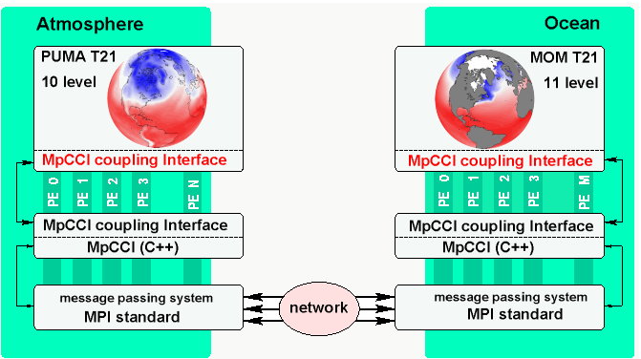

Fig. 1: Schematic view of the coupling for the components PUMA and MOM

MpCCI can be considered as a medium level programming interface which hides all the details of coupling (message passing, search for neighborhood, interpolation, and more).
For each code the communication via MpCCI is invoked by calls to library
subroutines. Portability of MpCCI is guaranteed by using MPI for the parallelization of MpCCI itself. A communicator concept allows communication within certain groups of processes (one group for each parallel application code). In several projects MpCCI has been used successfully for simulation of fluid-structure and fluid-fluid interaction. Since coupling between ocean and atmosphere can be considered as interaction between two fluids as well, the MpCCI coupling library has been chosen for our project.

Only a small subset of library functions is needed to couple ocean and atmosphere models. It is necessary to define the grid partitions, the communication requirements, the nodes and
the elements of the grid. The data transfer as required by the coupling algorithm consists of a few steps: put local values into the interface, send them, wait and receive values from the remote application, and take them to the local mesh. The application is stopped by calling the finalize subroutine.

A coupled simulation on a PC-cluster
SCAI has had access to a16-node cluster of the Siemens HPC-line, Celsius 620, each node having two processors Intel PIII 600e. Per node there is one Gigabyte of memory and there are two disks (8.4 GB, U2W-LVD). The processors are connected by a fast SCI-Network. The operating system is Redhat Linux 6.1. There are Compiler for C, C++, f90, f77, and HPF. The Portland Group Fortran compiler has been used for our experiment.
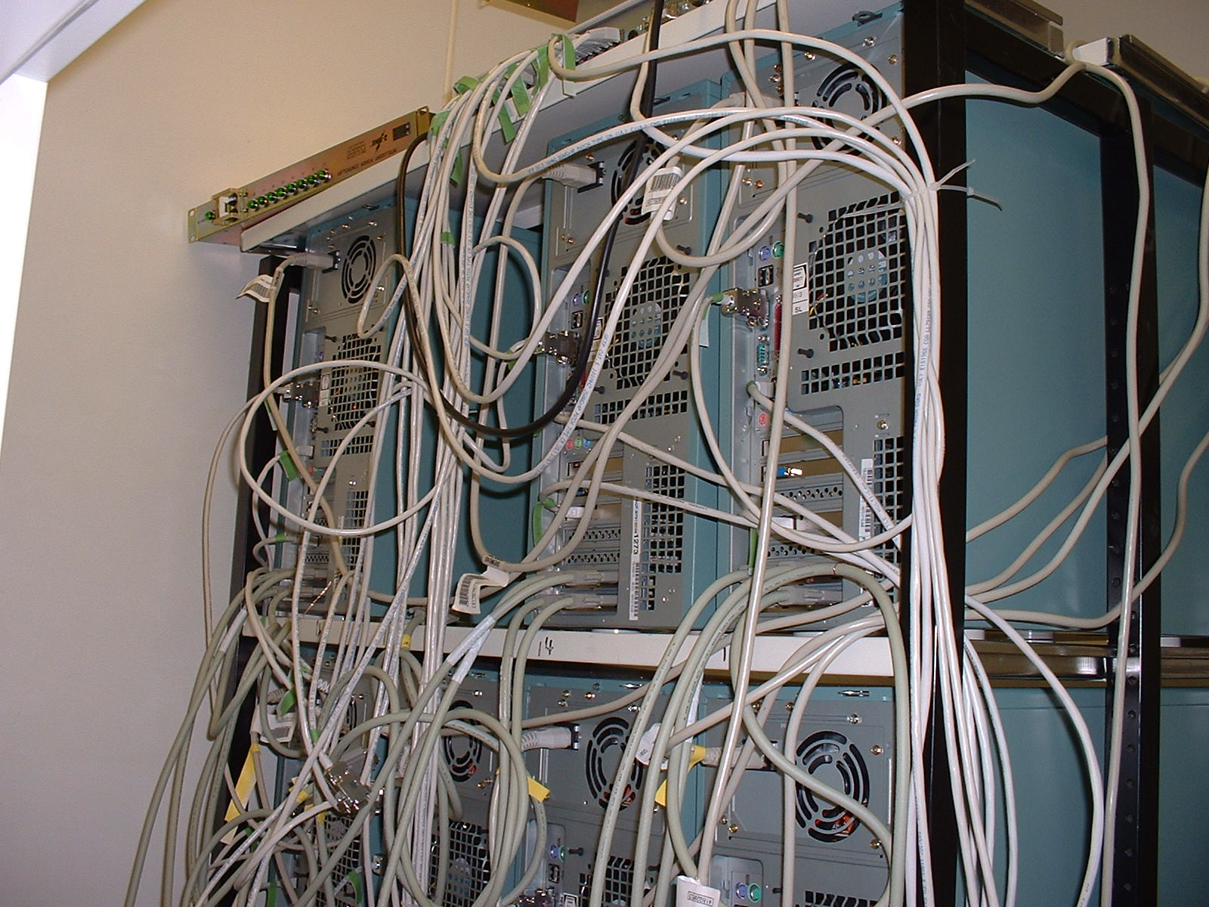
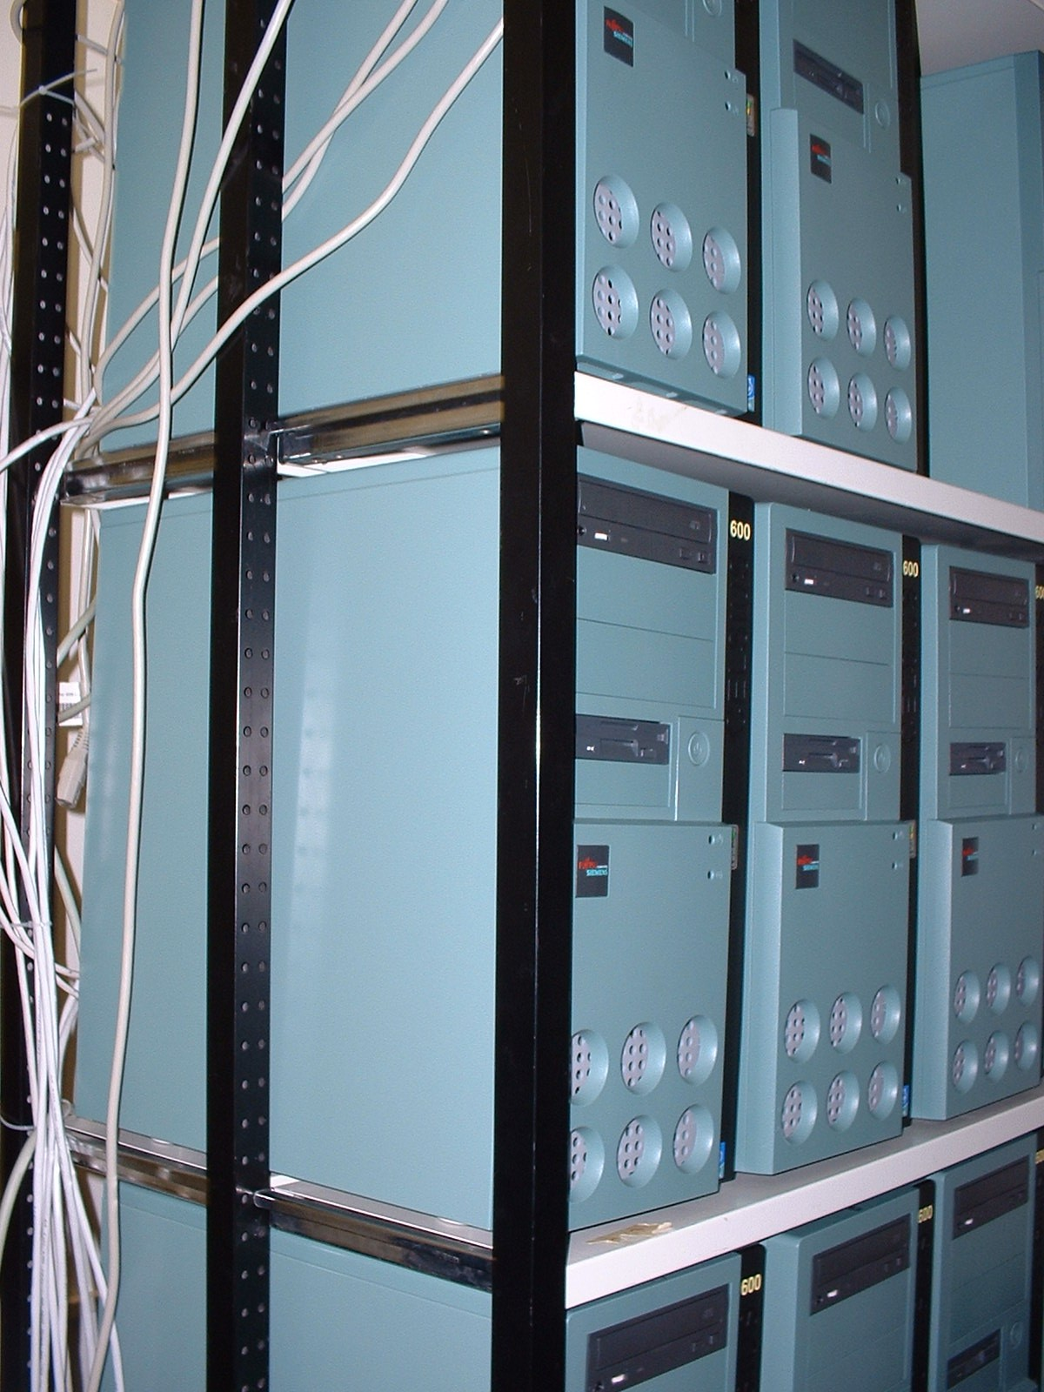

Fig. 2: Our PC-Cluster used for the coupled computation of PUMA and MOM

The resolution, as typical for climate simulation, is low: the horizontal grid size therefore is 32x64 and 64x128 grid-points for T21 and T42, respectively. The atmospheric model uses 10 vertical layers, whereas the ocean model runs with 11 levels. According to the space resolution, the time steps have to be adapted. For the atmosphere with T21 we use a 45 minutes time step, whereas the ocean uses 3 hours. T42 requires smaller step sizes, 30 minutes for the atmosphere and 2 hours for the ocean. The synchronization between ocean and atmosphere is done after every 4-th atmospheric time step. The experiments as described above have been run with the intention to demonstrate the technical applicability and stability of the coupling. It is also a question whether the exchange of coupling quantities decreases the overall performance significantly or not. This question is answered when looking at the results of the coupled simulations (columns and rows in Figure 3 with a number of processes larger than zero): the atmosphere still dominates and it becomes obvious that the simulation time for the coupled experiment has not increased dramatically.
For the T42 experiment PUMA running on 8 processors needs 3828 seconds. The coupled experiment with 8 processors for both PUMA and MOM finishes after 3843 seconds. The coupling overhead in this case is less than one percent, although there are 2160 exchanges of about 524 kilobytes each (5 variables from PUMA to MOM, and 3 variables vice versa).

Fig. 3: Measurements for half a year coupled simulation with PUMA and MOM

Numerical Analysis
With respect to extremely long simulation periods and short computation times the proper selection of time steps plays an important role. The classical von-Neumann stability analysis of time discretization schemes is applied here for model problems. Decision criteria are the numerical work, the position and size of the stability region as well as the relative error of phases and amplitudes.
Innovative solution techniques may become of interest when increasing the resolution. Higher resolution is of interest especially for coast lines and sea-ice edges. The quality of results is highly influenced by the proper resolution of the sea-ice cover, because depending on this the accurately calculated flow of heat may have major effects on the simulation. Within this project different error estimators are tested for their applicability in multigrid methods and especially in connection with sea ice edges changing with time.

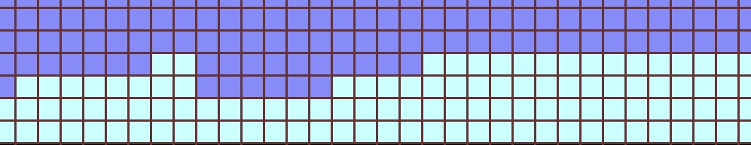
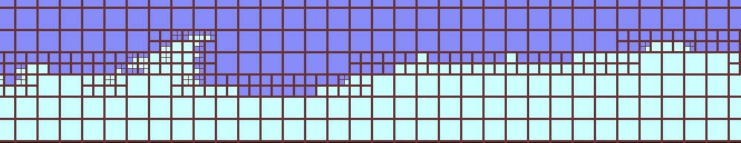

Fig. 3: Local refinement techniques at the Antarctic sea ice border

Interactive simulation and visualization
The project provides a java-based graphical user interface for an integrated application of the coupled model. More, an interactive evaluation of the simulation results becomes possible. Based on the visualized results it will be able to decide whether the applied scenario should be continued or whether the user wants to modify the currently used parameters. This feature is of value especially for the use in education at universities and research institutes. For future use an expansion towards an innovative teaching and learning environment with web-based training techniques will be possible.

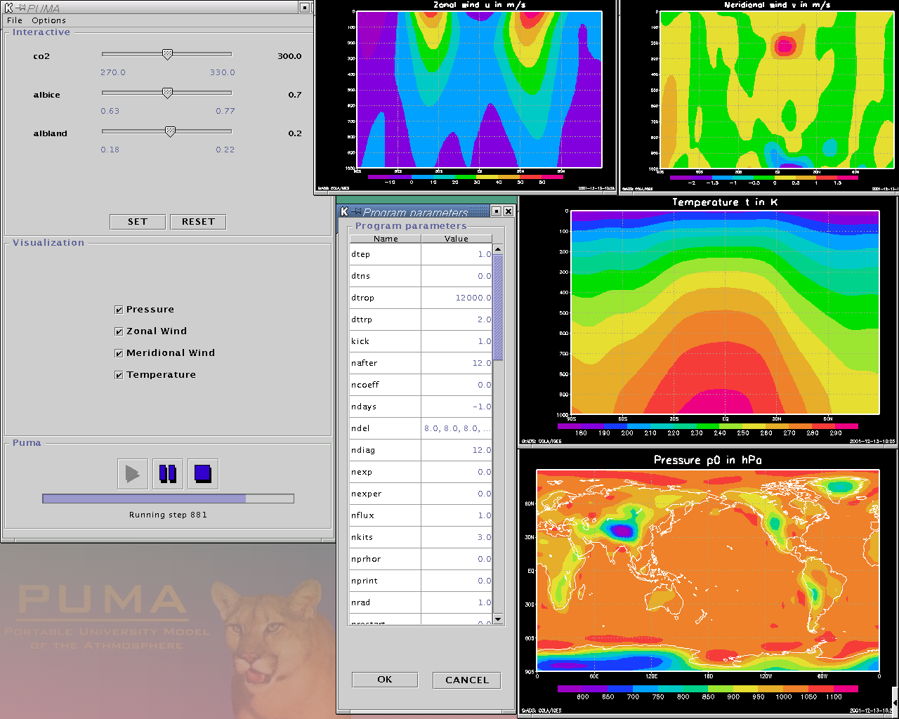

Fig. 5: Java-based user interface for interactive use of the planet simulator

Data assimilation using an icosahedral mesh
The activities with respect to the transport model using an Icosahedral grid (see Figure 6), have to consider both mathematical and computer science aspects. The decision to use the grid point model GME [Maj00] of the german weather service (DWD) offers several advantages for global transport calculations. They concern accuracy, scalability and portability.
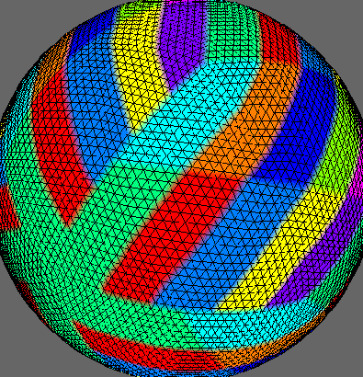
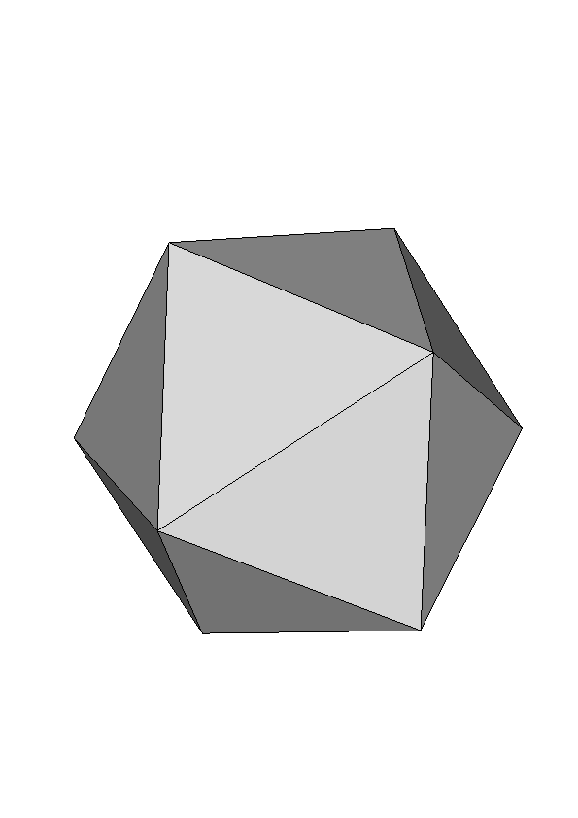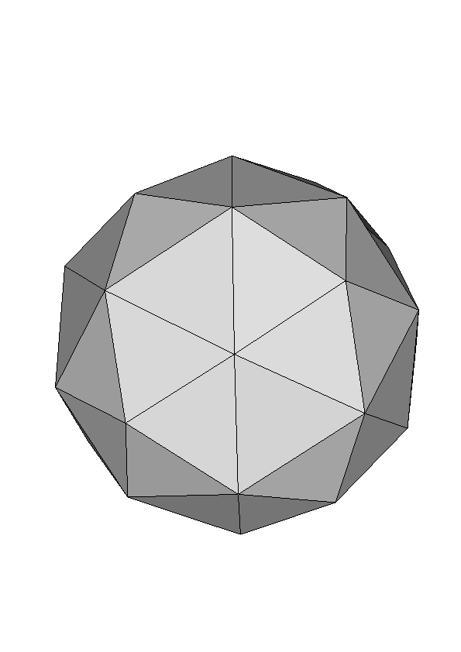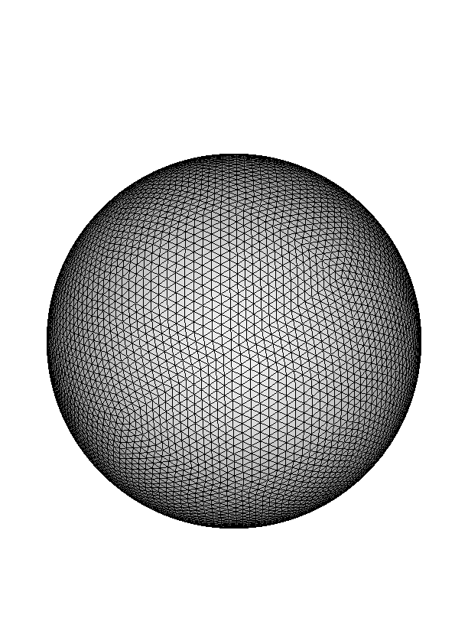
Fig. 6: Icosahedral mesh and partitioning strategy for parallel computations

There have been numerical experiments using different resolutions, initial conditions (real weather situations provided by the DWD), and parameter selections to find out the appropriate spatial resolution and meteorological processes to be included into the transport calculations. The calculations have to be finished within a narrow production window. It was found that the desired accuracy can be reached by subdividing each icosahedral diamond into 32x32 subintervals. The computing time for a one-day forecast is sufficiently small: four processors of a Compaq Alpha ES40 without any output finish within 5 minutes. This includes the use of all meteorological processes like radiation, precipitation, moisture convection, vertical turbulence, and others. The computation time on the above described PC-cluster for different resolutions and a different number of processes is shown in Figure 7. It turns out, that for 32x32 and 48x48 subintervals per icosahedral diamond, the application scales well only for a small number of processors.

Fig. 7: Computing a one day forecast with the GME on DEC (left) and on a PC-cluster (right)

Due to these experiences an algorithmic decision with respect to the data assimilation code has been made. The GME will calculate all required information for the adjoint model within a forecast run using all physical processes on the 32x32-grid and write out the meteorological fields and related information (like grid point information, departure points of semi-Lagrangian trajectories) onto local discs. These data offer best meteorological information and will be used when doing the optimization loop with forward and backward calculations.
Although the existing version of the SACADA-GME is a mixture of all relevant languages in scientific computing (Fortran77, Fortran90, C, and C++) the portability of the software has been shown by running the program on systems from Compaq, Sun and Siemens.

References
[MpCCI00] R. Ahrem, M.G. Hackenberg, U. Karabek, P. Post, R. Redler, and J. Roggenbuck. Specification of MpCCI. Technical Report 1.2, GMD-SCAI, Sankt Augustin, Germany, 2001.

[Frae98] K. Fraedrich, E. Kirk, and F. Lunkeit, Portable University Model of the Atmosphere. Technical Report No. 16, Deutsches Klimarechenzentrum, Hamburg, Germany, 1998.

[Hoskins75] B. J. Hoskins and A.~J. Simmons. A Multi-layer Spectral Model and the Semi-implicit Method. Q. J. Roy. Meteor. Soc., 101:637--655, 1975.

[Pacanowski00] R. C. Pacanowski and S. Griffies. MOM 3 Manual, GFDL Princeton, 2000.

[Maj00] D. Majewski, GME User’s Guide, Internal Report of the German Weather Service (DWD), Offenbach, Germany, 2000.

This project has been funded by the German Ministry for Education and Research under grant number 01LG9902.
2 This project has been funded by the German Ministry for Education and Research under grant number 07ATF50.

