Nnawili III. erTganzomilebiani modelebi

$3.1. Reros eiler-bernulis modeli

*Zeli* ewodeba sxeuls, romlis erTi zoma, sigrZe, or danar­CenTan SedarebiT Zalian didia, daaxloebiT xuTjer mainc aRemateba maT. SedarebiT grZel Zels *Rero* ewodeba. Ze­­li SeiZleba warmovidginoT, rogorc brtyeli figuris wrfis an wiris gaswvriv moZraobiT miRebuli sxeuli ise, rom figuris centri (geometriuli an simZimis) yovelTvis am wrfeze an Sesabamisad wirze rCebodes, xolo figuris sib­rtye misi perpendikularuli iyos. am figuras Zelis *ga­nivi kveTi­* ewodeba, xolo wirs, romlis gaswvri­vac moZ­rao­ba xdeba _ *Zelis RerZi*. RerZis formis mixedviT Zeli SeiZ­leba iyos *swori*, *mrudi*, *brtyeli*, *sivrciTi* da sxva. ga­nivi kveTis mixedviT ki Zeli aris *mudmiv*- an *cvlad­kve­Tia­ni*. Zelis*­­­* RerZis paraleluri wiris nawils, mokveTils ori ganivi kveTiT, boWko ewodeba (ix. [3], gv. 16).

Zelis *Runvas* iwveven ganivi Zalebi da wyvilZalebi, rom­lebic Zelis RerZze gamaval sibrtyeSi arian moTav­se­bul­ni. Zelebs, romlebic Runvas ganicdian, *koWebi* ewode­baT (ix. [3], gv. 160).

Tu koWs azrobrivad gavkveTT misi RerZis raime wer­til­Si gamavali ganivkveTiT, maSin kveTaSi moqmedeben *M* *mRu­navi momenti­* da *Q* *ganivi* (*gadamWreli*) *Zala*. amasTan mRu­navi momenti ricxobrivad udris kveTis cal mxares mo­debul reaqciis, Seyursuli da uwyvetad ganawilebuli Za­lebis kveTis centris mimarT aRebuli momentebis algeb­rul jams, xolo ganivi Zala _ kveTis cal mxares mode­bu­­li Zalebis kveTis sibrtyeze gegmilebis algebrul jams.

imisaTvis, rom kveTis mimarT marcxena da marjvena Zale­biT Sedgenili mRunavi momenti erTi da igive aRmoCndes ara marto sididiT, aramed niSniTac, SemoviRoT aseTi we­si: marcxena Zalis momenti miviCnioT dadebiTad, Tu igi kveTs uvlis saaTis isris mimarTulebiT, marjvena Zalisa ki _ sawinaaRmdegod. analogiuri wesi gveqneba ganivi Za­li­saTvis: marcxena ganivi Zala miviCnioT dadebiTad, Tu igi mimarTulia zemoT, marjvena ki _ Tu igi mimarTulia qve­moT (ix. nax 3.1.1, sadac dadebiTi mimarTulebebia naC­ve­ne­bi).

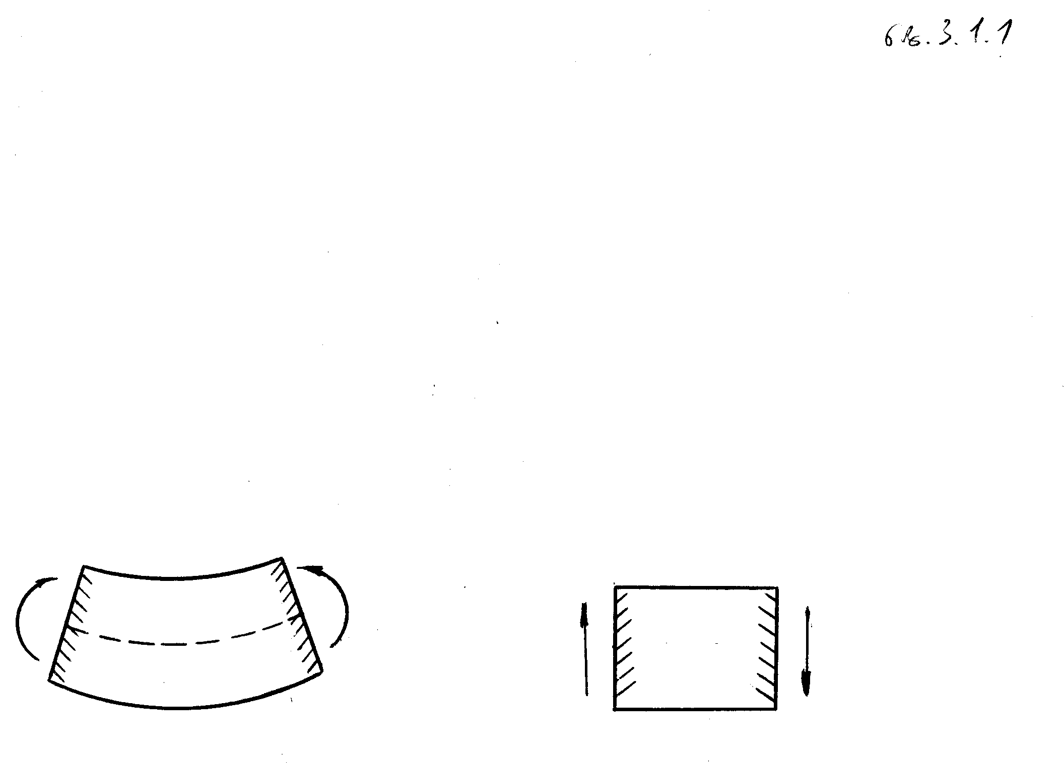

+M

+Q

nax. 3.1.1

Runvis zogad SemTxvevas, roca ZelSi arseboben mRunavi mo­menti da ganivi Zala, *ganivi Runva* ewodeba, xolo kerZo Sem­Txvevas, roca ganivi Zala nulia, _ *sufTa Runva*.

ganvixiloT koWi, romlis RerZi  RerZze mdebareobs, dat­virTuli uwyvetad ganawilebuli da Seyursuli Zale­biT. datvirTvis intensuroba *q*1 miviCnioT dadebiTad, roca is zemoTaa mimarTuli ( RerZis dadebiTi mimarTu­le­biT). Seyursul Zalebs Soris datvirTvis uwyveti cvli­le­bis gamo  da  agreTve uwyveti funqcie­bia. erT-erT aseT ubanSi gamovyoT koWis usasrulod mci­re  elementi (ix. nax 3.1.2) da SevadginoT misi wonas­wo­robis gantolebebi.

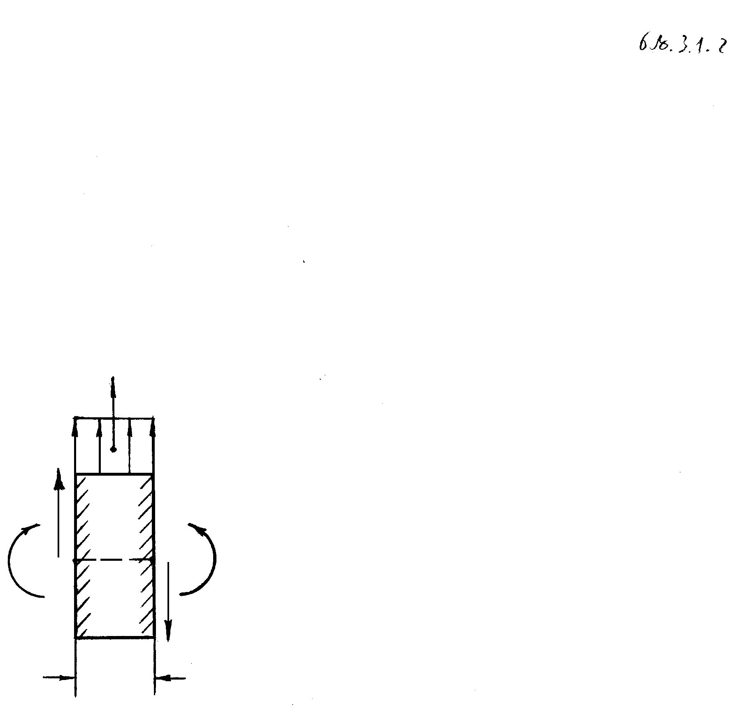

O

nax. 3.1.2

elementze moqmedebs ganawilebuli tvirTi da koWis ukug­debuli nawilebis reaqciebi, e.i. Siga Zalebi, rom­le­bic mRunavi momentiTa da ganivi ZaliT warmodgeba. rad­ga­nac  usasrulod mcirea, masze mosuli datvirTva SeiZ­le­ba Tanabrad ganawilebulad CavTvaloT: . Tu wertilSi gamaval ganiv kveTSi mRunavi momenti da ga­ni­vi Zala da -ia, maSin  wertilSi gamaval ga­niv kveTSi maTi mniSvnelobebi iqnebian  da . Zalebis vertikaluri gegmilebis jami (ix. [3], gv. 166)



,

saidanac

. (3.1.1)

amdenad, ganivi Zalis warmoebuli -iT sididiT da niS­niT udris datvirTvis intensiurobas.

*O* wertilis mimarT (ix. nax. 3.1.2) momentebis jami

,

saidanac meore rigis usasrulod mcire sidideebis ukug­de­bis Semdeg miviRebT, rom

. (3.1.2)

amdenad, mRunavi momentis warmoebuli -iT sididiT da niS­niT udris ganiv Zalas.

CavsvaT (3.1.2)-iT gansazRvruli -is gamosaxuleba (3.1.1)-Si, maSin



. (3.1.3)

SevniSnoT, rom Seyursuli Zalebis da momentebis modebis wer­tilebSi  da  funqciebis wyvetis gamo ma­Ti warmoebulebi azrs kargaven da am wertilebSi mire­bu­li diferencialuri damokidebulebebis gamoyeneba ar SeiZ­leba.

Runvis klasikur Teorias safuZvlad udevs *bernulis[1]*)* (anu *brtyeli kveTis*) hipoTeza, romelic SemdegSi mdgo­ma­reobs: Runvis dros ZelSi Cndeba ori zona: gaWimuli da Se­kumSuli, romelTa sazRvarze moTavsebulia *neitraluri* *Sre*, Semdgari iseTi boWkoebisagan, romlebic sig­rZes ar ic­vlian; ganivi kveTebi Runvis procesSi brtyeli da Ze­lis gaRunuli RerZis perpendikularulni rCebian; isi­ni, ro­gorc xisti firfitebi, Semobrundebian *neit­ra­lu­ri Rer­Zi­­­­s* (ix. nax. 3.1.3) garSemo, romelic neit-ra­lu­ri Sri­sa da ganivi kveTis sibrtyis gadakveTas warmoadgens (ix. [3], gv. 171).

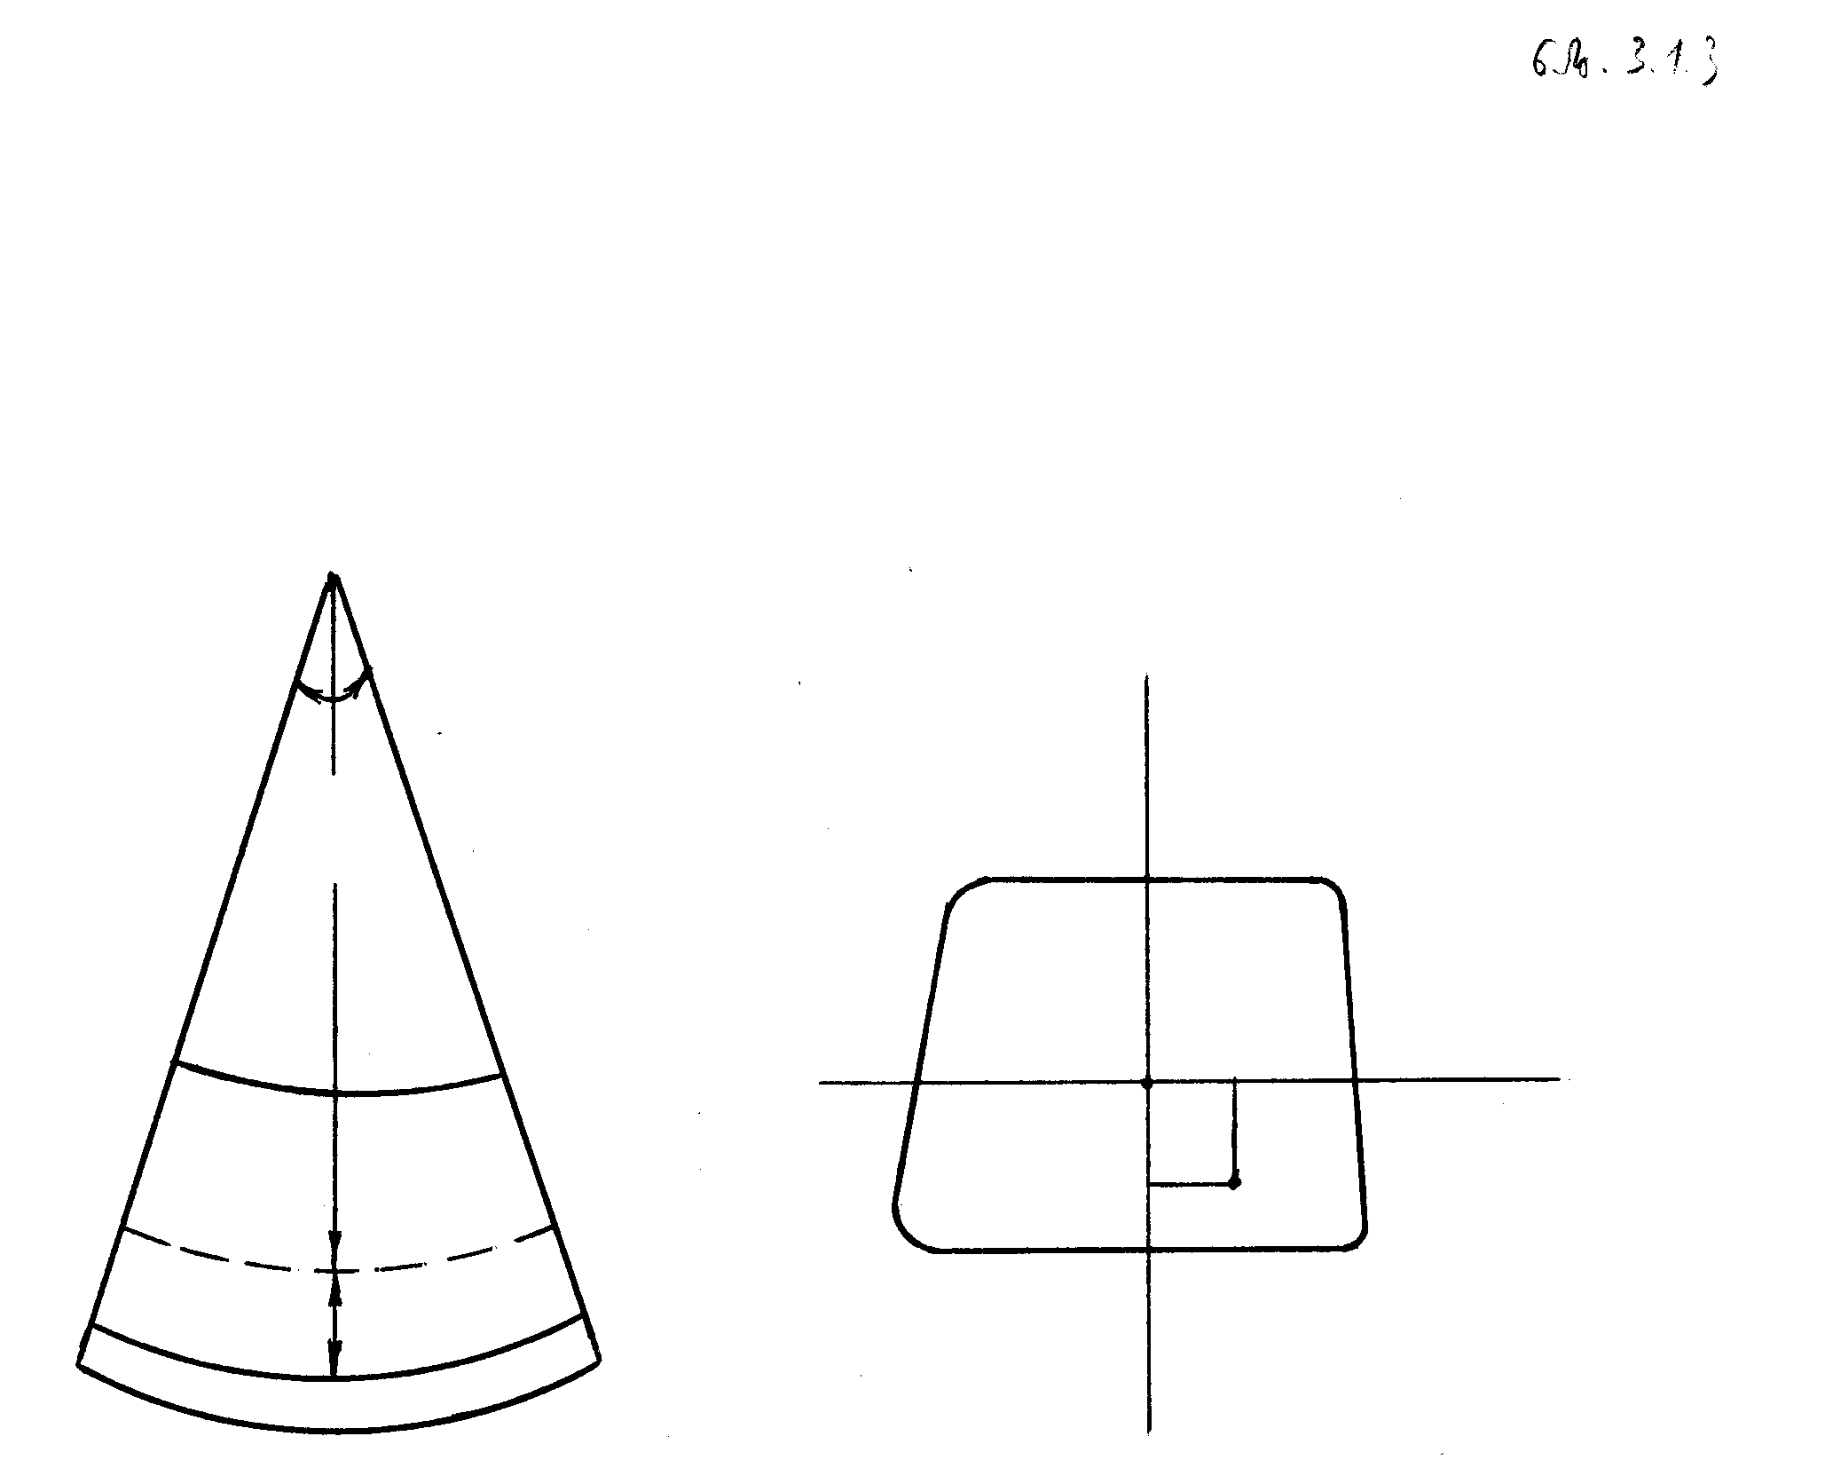

# O

# O2

# O1

neitraluri RerZi



# C

nax. 3.1.3

ori ganivi kveTiT gamovyoT usasrulod mcire  sig­rZis elementi (ix. nax. 3.1.3). *O* aris boWkoebis simrudis cen­­tri,  neitraluri Srea, *r* misi simrudis radiu­sia. gaWimul zonaSi aRebuli nebismieri *CD* boWkos sru­li wagrZeleba

,

sadac aris elementis boloebis urierTmobrunebis kuT­xe. cxadia, *CD* boWkos fardobiT deformacias aqvs



 (3.1.4)

saxe, sadac

 (3.1.5)

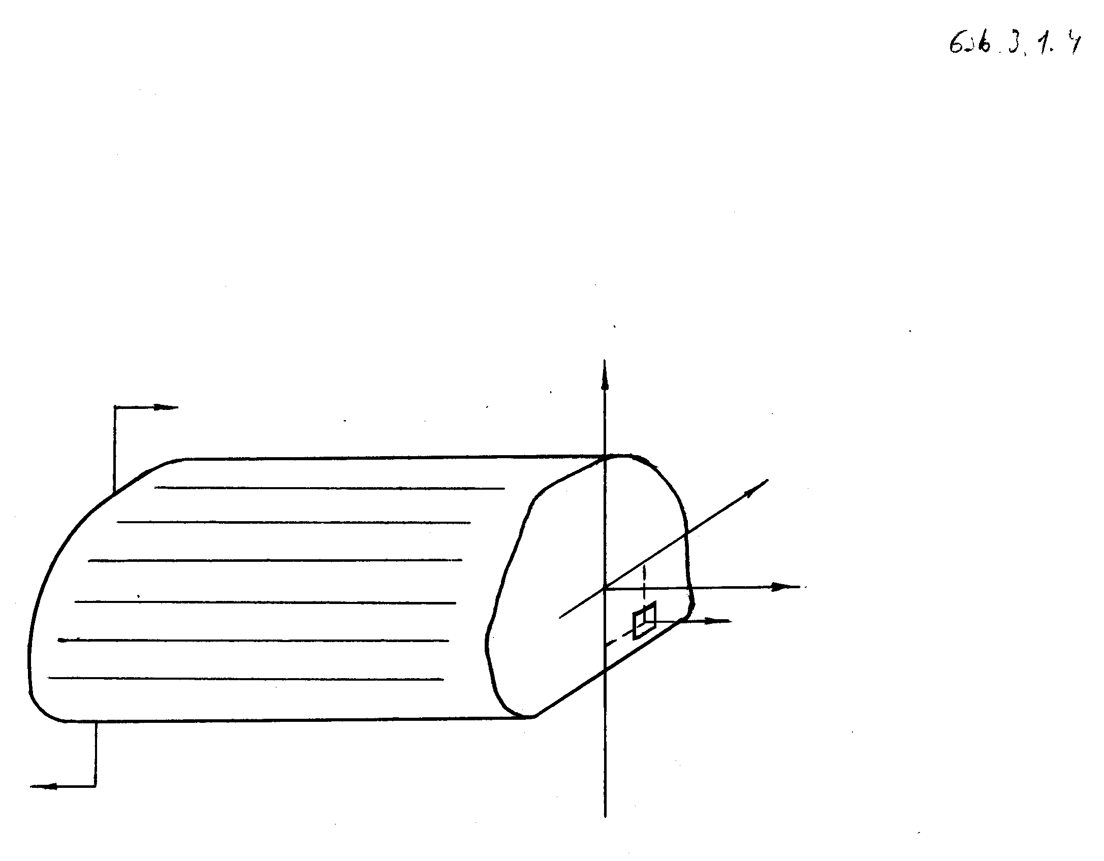

neitraluri RerZi



neitraluri Sris simrudea, xolo *w* misi CaRunvaa.

nax. 3.1.4

hukis



kanonSi CavsvaT (3.1.5), maSin

. (3.1.6)

wonasworobis moTxovnidan gamomdinare, Tu nuls ga­vu­to­lebT yvela Zalis moments neitraluri RerZis mimarT, mi­viRebT, rom

. (3.1.7)

Tu (3.1.6)-s CavsvamT (3.1.7)-Si, maSin

, (3.1.8)

sadac



warmoadgens e.w. *inerciis moments*  RerZis mimarT.

(3.1.7) tolobis dawerisas Cven vgulisxmobdiT, rom Run­va gamowveulia mxolod wyvilZaliT. Tu ganivi Zalac ar­sebobs, maSin kveTSi aRiZvreba mxebi Zabvebi, romlebic ko­Wis grZiv sibrtyeSi Zvras iwveven. maqsimalur Zvras ad­gi­li aqvs neitralur SresTan, Semdeg mcirdeba da ga­na­pi­ra boWkoebTan ispoba. Zvris Sedegad koWis RerZi ganivi kve­Tis marTobi ar rCeba, TviTon ganivi kveTi ki ci­lin­dru­li zedapiris formas miiRebs, romlis msaxveli neit­ra­luri RerZis paraleluri iqneba (ix. nax. 3.1.5). roca aRe­bul ubanSi , yvela kveTis gamrudeba erTnai­ria, ris gamoc *AB* boWko mxolod “xist gadaadgilebas” mii­Rebs da daikavebs  mdgomareobas, amasTan Zvris Se­de­gad is ar dagrZeldeba. cvladi ganivi Zalis SemTxvevaSi Tum­ca damatebiTi wagrZeleba Cndeba, magram metad umniS­vnelo, rac imis uflebas gvaZlevs, rom is ugulebelvyoT da normaluri Zabvebis gamosaTvlelad gamoviyenoT



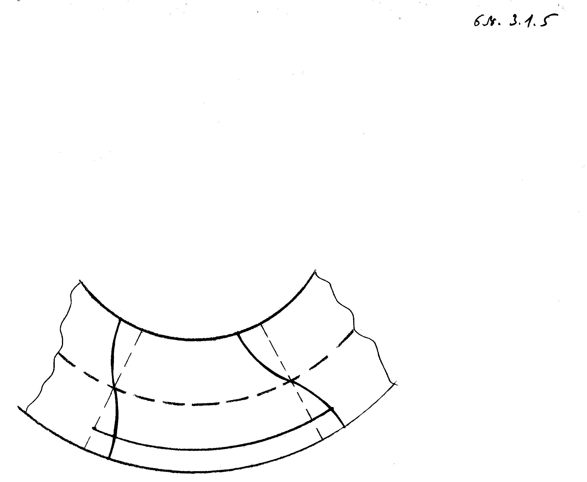

*A*

*A*1

*B*1

## B

neitraluri Sre

formula, romelic (3.1.8)-is (3.1.6)-Si CasmiT miiReba.

nax. 3.1.5

Tu vigulisxmebT, rom  CaRunva da misi  war­moe­bu­li, romelic deformaciis Sedegad gaRunuli Reros Rer­Zis mier  RerZTan Sedgenili kuTxis tangensia, mci­re sidideebia, maSin  aRniSnuli kuTxis tolad, xolo  erTis tolad SeiZleba CavTvaloT. amis gaTva­lis­winebiT, (3.1.5)-is (3.1.8)-Si Casmis Semdeg davaskvniT, rom

. (3.1.9)

(3.1.9)-is (3.1.3)-Si Casma gvaZlevs cvladi ganivi kveTis mqo­ne Reros (Zelis, koWis) Runvis Semdeg gantolebas:

. (3.1.10)

Tu Reros ganivi kveTa erTeulis toli siganisa da  simaRlis (e.i. Reros sisqis) mqone marTkuTxedia, maSin

.

(3.1.10) gantolebas unda daematos sasazRvro pirobebi Re­ros boloebSi. aseTia Semdegi sami ZiriTadi sasazRvro pi­roba:

1) *xistad Camagrebuli bolo*: am SemTxvevaSi Reros bo­los ar SeuZlia vertikalurad moZraoba da mobruneba, rac maTematikurad ase Caiwereba:

; (3.1.11)

2) *saxsrulad dayrdnobili bolo*: am SemTxvevaSi Re­ros bolos ar SeuZlia vertikaluri moZraoba, magram SeuZ­­lia mobruneba, rac maTematikurad ase Caiwereba:

; (3.1.12)

3) *Tavisufali bolo*: am SemTxvevaSi Reros bolos SeuZ­lia rogorc vertikaluri moZraoba, aseve Semobruneba, rac maTematikurad ase Caiwereba:

. (3.1.13)

dinamikis amocanebis ganxilvisas, dalamberis principis Tanax­mad, datvirTvas unda daematos  RerZis para­le­lu­ri inerciis



Zala, sadac  Reros simkvrivea, xolo  Reros ga­ni­vi kveTis farTia. amdenad, Reros dinamikis gantolebas, (3.1.10)-is ZaliT, aqvs

 (3.1.14)

saxe.

Reros dinamikis amocanebis ganxilvisas (3.1.11)-(3.1.13) ti­pis sasazRvro pirobebs unda daematos

 (3.1.15)

sawyisi pirobebi.

(3.1.11)-(3.1.15) pirobebi SeiZleba araerTgvarovanic iyos.

Tu  Reros raime wertilebSi, kerZod, bo­loeb­­Si, maSin mas wamaxvilebuli Rero ewodeba.

wamaxvilebuli Reros statikisa da dinamikis ZiriTadi amo­canebis dasmis Taviseburebebi da TviT sasazRvro da saw­yis-sasazRvro amocanebi, kerZod, arawamaxvilebuli Re­roe­bis SemTxvevaSic, gamokvleulia [23]-Si.

$3.2. Reroebis ierarqiuli modelebi

vTqvaT, Reros ukavia  sivrcis  nawili,

,

sadac  da  marTkuTxa ganivi kveTis mqone Reros, Se­sa­bamisad, sisqe da siganea, romelTa maqsimumebi ar­se­bi­Tad naklebia Reros *L* sigrZeze.

davuSvaT, rom

,

da  wertilSi, sadac arc sisqe da arc sigane nuli ar xde­ba, Semdegnairad ganvsazRvroT funqciisa da misi  war­moebulis ormagi momenti:

 (3.2.1)

 (3.2.2)

sadac

,

, leJandris polinomebia. cnobilia, rom (ix. da­mateba 2 an magaliTad, [4]):

,

e.i. Tu , 

 (3.2.3)

Tu erTi mainc, Reros an sisqe, an sigane nuli xdeba rai­­me  wertilSi, maSin am wertilSi ormagi mo­men­­ti ganisazRvreba, rogorc zRvari im wertilebidan, sa­dac , .

am paragrafis mizania agebuli iqnes i. vekuas mier priz­mu­­li garsebis SemTxvevaSi agebuli ierarqiuli modelebis ana­­lo­giuri ierarqiuli modelebi marTkuTxa kveTis mqo-

ne Re­­­roebisaTvis (es sakiTxi dawvrilebiTaa ganxiluli [21]-Si).

amisaTvis (1.6.3). (1.12.9) da (1.18.1) damokidebulebebis ori­ve mxare gavamravloT -ze da Semdeg vaintegroT -is mimarTA,  , saz­Rvreb­Si. (1.12.9)-dan uSualod miviRebT, rom



 (3.2.4)

xolo (3.2.2)-isa da (3.2.3)-is gamoyenebiT, garkveuli ga­moT­vlebis Semdeg, Tu , deformaciis tenzoris kom­ponentebis ormagi momentebisaTvis miviRebT Semdeg ga­mo­saxulebebs:

 (3.2.5)

, (3.2.6)

 (3.2.7)

 (3.2.8)

sadac

 (3.2.9)



amasTan

 (3.2.10)

da mwkrivebi (3.2.5)–(3.2.8), (3.2.10)-Si Tanabrad krebadia -ze.

moZraobis (1.18.1) gantolebebi ki ormag momentebSi Sem­de­gi saxiT Caiwereba:

 (3.2.11)

sadac





 (3.2.12)





warmoadgenen , , zedapirze Reros ga­re­dan moqmed zedapirul ZalTa komponentebs.  , Se­sa­ba­misi gare normalebia.



(3.2.11) SeiZleba gadmovweroT Semdegi saxiTac:





. (3.2.13)

axla davuSvaT, rom

 (3.2.14)

Tu sruldeba erTi mainc Semdegi ori pirobidan

.

am SemTxvevas vuwodebT  miaxloebas.

 miaxloebaSi (3.2.9)-dan miviRebT, rom





 (3.2.15)

sadac

,

radgan





(3.2.14), (3.2.15), (3.2.9)-is gaTvaliswinebiT (3.2.5)-(3.2.8) da (3.2.4)-dan gamomdinareobs, rom



,









,



(3.2.16)







 (3.2.17)

 (3.2.18)

,





 (3.2.19)

.

(3.2.16)-(3.2.19)-is Casma (3.2.13) sistemis pirvel  gantolebaSi fiqsirebuli -saTvis gvaZlevs Semdeg  gantolebisagan Semdgar sistemas 

,

ucnobis mimarT:



 (3.2.20)

sadac



,  gamosaxulia , , , ,  sidideebiT, amasTan zogierTi maTgani nulia, zo­gier­Ti ki, sazogadod, SemousazRvravia ]0,L[-ze. mar­Tlac, Tu 



















 (3.2.21)

Tu :

















 (3.2.22)

sadac

,

e.i.



















.

advili misaxvedria, rom iq, sadac Reros sisqesa da si­ga­nidan erTi mainc nulis tolia, sistemas aqvs rigis ga­dag­vareba -is Sesabamisi mniSvnelobebisaTvis.

**3.2.1. sawyis-sasazRvro amocanebi**

ganvixiloT  miaxloeba. davuSvaT, rom Reros , , zedapirebze moqmedeben zedapiruli Za­le­bi (ix. (3.2.12)), xolo boloebze, romlebic  da  sibrtyeebis marTkuTxa nawilebs warmoadgenen, mo­ce­mulia gadaadgilebis an zedapiruli Zalebis komponen­te­bi. Tu  da , , maSin Reros bo­loeb­ze ormagi momentebisaTvis sasazRvro pirobebi SeiZ­le­ba Semdegnairad daisvas.

1. sasazRvro pirobebi gadaadgilebebSi:

 (3.2.23)

aq  boloebSi dasaxelebuli mudmivebia. dinamikur Sem­Txve­vaSi maT emateba

 (3.2.24)

sawyisi pirobebi, sadac ,  mocemuli funqciebia, xolo , sazogadod, *t*-ze damokidebuli funqciebia.

2. sasazRvro pirobebi ZabvebSi:

 (3.2.25)

aq  boloebSi dasaxelebuli mudmivebia.

3. Sereuli sasazRvro pirobebi: am SemTxvevaSi Reros erT-erT boloSi (3.2.23) pirobebia mocemuli, xolo meore bo­loSi _ (3.2.25); an *j*-s raime mniSvnelobebisaTvis mo­ce­mu­lia (3.2.23) pirobebi, xolo danarCenisaTvis _ (3.2.25).

Tu Reros boloSi , sidideebidan erTi mainc xdeba nuli, maSin marcxena mxareebi (3.2.23)-sa da (3.2.25)-Si unda gavigoT, rogorc zRvrebi ]0,*L*[ inter­va­li­dan. zog SemTxvevaSi (3.2.23) pirobebi icvleba Sesa­ba­mi­si -ebis SemosazRvrulobiT.

dasmuli amocanebis gamosakvlevad SeiZleba warmatebiT iq­nes gamoyenebuli cnobili samecniero literatura Cveu­leb­riv diferencialur gantolebaTa (ix., magaliTad, [46]) da hiperbolur gantolebaTa (ix. magaliTad, [49]) Teo­ria­Si. Tumca maTi gamoyeneba moiTxovs garkveul damatebiT ga­mok­vlevebs, gansakuTrebiT wamaxvilebul, e.i., roca , , , Reros SemTxvevaSi.

roca , , , imis gaT­va­lis­wi­ne­biT, rom (3.2.21), (3.2.22) sistema statikur SemTxvevaSi SeiZ­leba dayvanil iqnes pirveli rigis wrfiv Cveulebriv dife­rencialur gantolebaTa sistemaze, dasmuli amo­ca­ne­bis amoxsnadoba regularul  funqciaTa klasSi, cno­bi­li Teoremis (ix. [46], gv. 146) Tanaxmad, gamomdinareobs ma­Ti amonaxsnebis erTaderTobidan. amonaxsnis erTaderTo­bis sakiTxi Seswavlilia [21]-Si.

roca , , , SeiZleba daisvas Semdegi sasazRvro pirobebi:

, Tu

; (3.2.26)

 Tu

; (3.2.27)

 Tu

; (3.2.28)

 Tu

; (3.2.29)









Tu  (3.2.30)

|  |  |
| --- | --- |
|  | (3.2.31) |

aq , , , mocemuli mud­mi­ve­bia,



,

.

(3.2.21), (3.2.22), (3.2.26), (3.2.27); (3.2.21), (3.2.22), (3.2.26), (3.2.31); (3.2.21), (3.2.22), (3.2.27), (3.2.30); (3.2.21), (3.2.22), (3.2.26), (3.2.29); (3.2.21), (3.2.22), (3.2.27), (3.2.28) sasazRvro amocanebi calsaxad amoxsnadia, xo­lo (3.2.21), (3.2.22), (3.2.28), (3.2.29) sasazRvro amo­ca­na amoxsnadia xisti gadaadgilebis sizustiT (ix. [21]). ana­lo­giuri daskvnebis gamotana SeiZleba ucnobi sidi­dee­bis indeqsebis mimarT Sereuli sasazRvro amocanebis mimar­Tac.

dinamikur SemTxvevaSi zemoxsenebul sasazRvro pirobebs ema­teba (3.2.24) sawyisi pirobebi. sawyisi pirobebis dasma, sa­saz­Rvro pirobebisagan gansxvavebiT, Reros wamaxvilebaze ar aris damokidebuli, radgan (3.2.21), (3.2.22) sistema ar aris gadagvarebuli *t*-s mimarT saerTod da, kerZod, roca .

-is TiToeuli konkretuli mniSvnelobis Sem­Txve­vaSi viRebT konkretul ierarqiul models _ miax­loe­bas. TiToeuli maTgani warmoadgens damoukidebel maTe­matikur models, romelsac damoukidebeli praqtikuli mniS­vne­loba gaaCnia. magaliTad, (0,0) miaxloeba Seesabameba Reros gaWimva-kumSvis klasikur models, xolo (1,0) miax­loe­ba _ Reros klasikuri Runvis models koeficientebis sizus­tiT.

wamaxvilebuli Reroebisa da firfitebis koreqtulad das­muli sasazRvro amocanebis mimarTebis sakiTxi samgan­zo­milebiani modelis sasazRvro amocanebTan ganxilulia [22]-sa da [24]-Si.

**3.2.2. (0,0) miaxloeba**

(0,0) miaxloebaSi (3.2.21), (3.2.22) sistema iRebs Semdeg sa­xes:

 (3.2.32)

.

rogorc vxedavT, sistema daiSala sam damoukidebel er­Ti da imave tipis gantolebad. advili sanaxavia, rom sta­ti­kur SemTxvevaSi (e.i., (3.2.32)-is marjvena mxareSi nu­lia)

, (3.2.33)

da maT zogad amonaxsns  klasSi aqvs



saxe.

(3.2.26)-(3.2.31) sasazRvro pirobebi iReben

 (dirixles piroba),

|  |  |
| --- | --- |
| Tu , | (3.2.35) |

 (dirixles piroba),

|  |  |
| --- | --- |
| Tu , | (3.2.36) |

, Tu , (3.2.37)

, Tu , (3.2.38)

 (neimanis woniani piroba),

|  |  |
| --- | --- |
| Tu , | (3.2.39) |

 (neimanis woniani piroba),

|  |  |
| --- | --- |
| Tu , | (3.2.40) |

saxes, sadac , , , mocemuli mudmivebia.



vTqvaT, , e.i. integrebadia (jamebadia) da Tu  , maSin is iseTia, rom (3.2.34)-Si ite­rirebuli integrali iyos SemosazRvruli, roca .

Tu  lokalurad jamebadia -Si, maSin (3.2.34)-dan gamomdinareobs, rom regularuli amonax­sni­sa­T­­vis (e.i. ) mxolod Semdegi amocanebia ko­req­­tuli (3.2.33), (3.2.35), (3.2.36) (); (3.2.33), (3.2.37), (3.2.36) (); (3.2.33), (3.2.35), (3.2.38) (); (3.2.33), (3.2.37), (3.2.38); (3.2.33), (3.2.35), (3.2.40) (, ); (3.2.33), (3.2.39), (3.2.36) (,  ); Sereuli amocanebi, roca erT boloSi *j*-is zo­gier­Ti mniSvnelobisaTvis mocemulia dirixles piroba, xo­lo *j*-is danarCeni mniSvnelobisaTvis mocemulia an nei­ma­nis, an (3.2.37), (3.2.38) tipis piroba, xolo meore boloSi *j*-is pirveli mniSvnelobisaTvis mocemulia an dirixles, an nei­manis, an (3.2.37), (3.2.38) tipis piroba, xolo *j*-is da­nar­Ceni mniSvnelobisaTvis mocemulia dirixles (neimanis da (3.2.37), (3.2.38) tipis piroba dasaSvebi ar aris) pi­ro­ba, roca meore boloSi neimanis pirobaa mocemuli da di­rix­les an (3.2.37), (3.2.38) tipis piroba (neimanis piroba da­saSvebi araa), roca meore boloSi (3.2.38), (3.2.37) ti­pis pirobaa mocemuli.

(3.2.33), (3.2.37), (3.2.38) sasazRvro amocanis amonaxsni gan­sazRvrulia xisti gadatanis (; , , ne­bis­mieri mudmivebia) sizustiT. es asec unda iyos, radgan am SemTxvevaSi Reroze, rogorc samganzomilebian sxeulze, moq­medeben mxolod zedapiruli Zalebi, romlebic Seta­ni­lia , , gamosaxulebebSi. SevniSnoT, rom fi­zi­kuri (meqanikuri) mosazrebebidan gamomdinare, bunebrivia, rom Cven im sasazRvro amocanebs, romelTa amonaxsnebi xis­ti gadaadgilebis sizustiT ganisazRvreba, koreqtulad _ “kar­gad” dasmuli vuwodoT.

advili sanaxavia, rom orive boloSi neimanis pirobis da­sa­xeleba dasaSvebi (SesaZlebeli) ar aris. is SeiZleba mxo­lod erT boloSi dasaxeldes da amasTan amonaxsni xis­ti gadatanis sizustiT iqneba gansazRvruli, rac buneb­ri­via, radgan Reroze moqmedeben mxolod zedapiruli Zalebi erTi bolos CaTvliT, xolo meore bolo saerTod ganTa­vi­suflebulia sasazRvro pirobebisagan. xazgasasmelia, rom es Tavisebureba Reros wamaxvilebiT ar aris gamowveuli. es (0,0) modelis siuxeSidan gamomdinareobs, aseve ar arian amoxsnadi (3.2.33), (3.2.37), (3.2.40) da (3.2.33), (3.2.38), (3.2.39) sasazRvro amocanebi (romlebic mxolod wa­maxvilebuli RerosaTvis warmoiSvebian), radgan am Sem­Txve­vebSi  da SeuZlebelia  mudmiviT (3.2.40) da (3.2.39) pirobebis dakmayofileba.

(0,0) miaxloebaSi dinamikis amocana dirixles pirobebis (im SemTxvevis CaTvliT, roca wamaxvilebuli bolo Tavi­suf­ldeba sasazRvro pirobisagan) SemTxvevaSi, roca Reros mxo­lod erT boloSi aqvs xarisxovani wamaxvileba, gamok­vleu­lia [26]-Si. dinamikis amocanebi danarCeni zemoT mi­Ti­Te­buli sasazRvro pirobebis SemTxvevaSi Semdgomi kvlevis sa­gans warmoadgens.

**3.2.3. (1,0) miaxloeba**

simetriuli Reroebis SemTxvevaSi, e.i. roca , , (1,0) miaxloebaSi (3.2.21), (3.2.22) sistema iRebs Sem­deg saxes:

, (3.2.41)

 (3.2.42)

, (3.2.43)

, (3.2.44)

, (3.2.45)

 (3.2.46)

sasazRvro amocanebi (3.2.43) gantolebisaTvis gamok­vleu­li iyo 3.2.2 qveparagrafSi. aqedan gamomdinare, maga­li­Tad, dirixles pirobebi v200-saTvis SeiZleba dasmuli iqnes mxolod maSin, roca , . anlogiurad SeiZ­leba gamokvleul iqnes (3.2.44) gantolebac, rac im das­kvnamde migviyvans, rom am gantolebisaTvis da e.i. -saT­vis dirixles pirobebi SeiZleba dasmul iqnes mxolod ma­Sin, roca , . am SemTxvevaSi

,

saidanac

,

roca  , an roca  , mag­ram  SemosazRvrulia, Tu  .

(3.2.45), (3.2.46) da (3.2.41), (3.2.42) sistemebi SeiZleba Sem­degi saxiT gadavweroT:







da







.

am sistemebis upiratesoba isaa, rom maT So­ris meore gan­to­lebebi mxolod erT ucnobs Seicaven da ma­Ti amox­snis Semdeg pirveli gantolebebidan advilad daiT­vleba  da .

erTi boloTi xarisxobrivad wamaxvilebuli Reros Sem­Txve­vaSi dinamikis amocanebi, roca sasazRvro pirobebi di­rix­les tipisaa, gamokvleulia [26]-Si. sxva tipis sa­saz­Rvro amocanebisa da Sesabamisi dinamikis amocanebis Ses­wav­la Semdgomi kvlevis sagania.

nawili IV. drekad da Txevad garemoTa urTierTqmedebis amocanebi

$4.1. transmisiis (sakontaqto) pirobebi

siTxisa da drekadi sxeulis urTierTqmedebis amocanebi Ta­named­rove aqtualur samecniero Tematikas ganekuTvnebian. maTi mniSvneloba ganpirobebulia, magaliTad, navTobis nav­Tob­sadenebSi, sisxlis sisxlZarRvebSi moZraobis, sanapiro ga­mag­rebis amocanebis aqtualobiT. dReisaTvis mimdinareobs amo­canebis intensiuri kvleva *interfeisze* (sxeulis Txe-va­di da myari nawilebis gamyof sakontaqto zedapirze) sxva­­das­xva *transmisiis* anu *sakontaqto* pirobebis Sem­Txve­va­Si. amasTan kvlav grZeldeba fizikuri TvalsazrisiT ga­mar­Tlebuli sakontaqto pirobebis dadgenis procesi [42], [56], [18], [7-10].

samganzomilebian modelebSi Cveulebriv iyeneben

 (4.1.1)

sakontaqto pirobebs, sadac , da , , , aris gadaadgilebis veqtoris da Zabvis ten­zo­ris komponenetebi Sesabamisad sxeulis myar da Txevad na­wi­lebSi;  da  Sesabamisad -is da -is gare nor­malebia, xolo *I* aris interfeisi myar da Txevad na­wi­lebs Soris.



gamokvleulia agreTve zogierTi amocana Semdegi uni­la­te­raluri (calmxrivi) sakontaqto pirobebiT [7]:

 (4.1.2)

, (4.1.3)

, (4.1.4)

da , Tu . (4.1.5)

(4.1.3) imas niSnavs, rom *I* interfeisze mxolod normaluri Zab­vebi moqmedeben (mxebi komponenetebi nulis tolia,  nor­maluri komponentia, *N* interfeisis gare normalia -is mimarT), romlebic erTmaneTs awonasworeben; (4.1.4) niS­navs imas, rom gvaqvs kumSva; (4.1.5) ki imas niSnavs, rom Tu myari da Txevadi nawilebi interfeisis raime wer­til­Si erTmaneTs ar ebjineba, maSin am wertilSi nor­ma­luri Za­lebi nulis tolia.



ganixilaven agreTve sakontaqto pirobebs samgan­zo­mi­le­bian siTxesa da drekad garss an firfitas Soris. vTqvaT, siT­­xe iwvevs firfitis Runvas. Tu ganvixilavT Runvas kirxhof-liavis modelis safuZvelze, maSin, ramdenadac yve­la geometriuli da fizikuri sidide gamoisaxeba CaRun­viT, sakontaqto pirobebad SeiZleba gamoviyenoT (4.1.1) an (4.1.2)-(4.1.5) pirobebi. sakontaqto pirobebis modelireba Sem­degnairadac SeiZleba. vTqvaT, firfitis Sua sibrtye mde­bareobs  sibrtyeze da siTxis nakadi iwvevs fir­fi­tis Runvas. maSin firfitis datvirTvis intensio­bisaT­vis gveqneba

 (4.1.6)



gamosaxulebebi, xolo siTxis  siCqaris mniS­vne­lo­ba firfitis piriT zedapirebze da firfitis *w* CaRunva Sem­degi tolobebiT iqnebian dakavSirebulni:







, (4.1.7)



, (4.1.8)



 (4.1.9)

((4.1.7)-Si meore toloba samarTliania imis gamo, rom  CaRunva ar aris damokidebuli -ze), sadac *ω* aris firfitis gegmili  sibrtyeze,  aris firfitis zeda da qveda piriTi zedapirebi. rogorc vxe­davT (4.1.6)-(4.1.9) sakontaqto pirobebSi yvela funqcia drois yvela momentSi damokidebulia  wer­ti­leb­ze da amdenad sakontaqto pirobebi faqtobrivad Cawe­ri­li gvaqvs *ω* areSi.

Tu firfita sakmarisad Txelia, (4.1.6)-(4.1.9) sakon­taq­to pirobebi SeiZleba kidev ufro gavamartivoT Semdeg daS­vebebze dayrdnobiT:

1) CavTvaloT, rom siTxes ukavia  are;

2) CavTvaloT, rom drekad nawils ukavia are (misi geo­metria sisqis gaswvriv gaTvaliswinebulia Runvis gan­to­lebis koeficientebSi);



3) mcire sidideebis ukugdebis Semdeg (4.1.7)-(4.1.9) sakon­taqto pirobebi Semdegnairad Caiwereba

 (4.1.10)

4) -is ugulebelyofisa da imis gaTvalis­wine­biT, rom sibrtyis nawilis normalebia  da , (4.1.6) miiRebs



 (4.1.11)

saxes.

idealuri siTxis SemTxvevaSi

,

sadac wnevaa. amitom





da (4.1.6) sakontaqto piroba miiRebs



|  |  |
| --- | --- |
|  | (4.1.12) |

saxes.

Tu kuTxe -sa da  RerZs Soris mcirea, maSin (4.1.11) SeiZleba Semdegi saxiT CavweroT



 (4.1.13)

zogierTi sakontaqto amocana (4.1.10), (4.1.11) da (4.1.10), (4.1.12) sakontaqto pirobebSi gamokvleulia [8-10]-Si.

Tu siTxeSi Cadebulia drekadi firfita an Rero, maSin Se­sa­bamisad *N*-uri (ix. $2.6) da  (ix. $3.2) ierar­qiu­li modelebis gamoyenebis dros (4.1.1)-(4.1.5) sakon­taq­to pirobebSi  da  sidideebis nacvlad unda CavsvaT maTi *N*-uri da  miaxloebiTi mniSvnelobebi.

 da (0,0) miaxloebaSi (4.1.1) pirobebs SeiZleba sxva saxec mieces.

magaliTad,  miaxloebaSi (4.1.1) pirobebi SeiZleba Sem­degi saxiT Caiweros:



da, mudmivi sisqis SemTxvevaSi,







,

xolo cvladi sisqis SemTxvevaSi





,





(0,0) miaxloebaSi (4.1.1) pirobebi Semdegi saxiT Cai­we­re­ba (ix. (3.2.12)):

;



.

statikur SemTxvevaSi ukanaskneli sami diferencialuri to­lobis -is mimarT integrebiT TiToeulisaTvis ori ucnobi mudmivis Semcvel integralur damokidebulebas mi­vi­RebT -ze.



amocanebi aseTi sakontaqto pirobebiT jer-jerobiT gamok­vleuli ar aris.

(4.1.1)-(4.1.5) sakontaqto pirobebi gamoiyeneba agreTve dre­kadi sxeulebis urTierTqmedebis interfeisze (ix. [56], Ta­vi 6).

$4.2. drekadi da Txevadi nawilebisagan Semdgari

sxeulis rxeva

ganvixiloT *myari drekadi nawilisa* da *Txevadi nawi­li­sa­gan* *Semdgari sxeulis* (kompoziciuri garemos) wertile­bis mcire gadaadgilebebi drekadobis wrfivi da siTxeebis mos­venebuli mdgomareobis mimarT gawrfivebuli Teoriis sa­fuZvelze. vTvliT, rom myari da Txevadi nawilebi siv­rceSi perioduladaa ganawilebuli (mcire periodiT). mya­ri nawili (*faza*) SeiZleba iyos bmuli, romelic Sedgeba er­Ti myari sxeulisagan arxebiT, sadac siTxe moZraobs, an arabmuli, e.i. siTxeSi Cadebulia myari nawilakebi. davuS­vaT, rom siTxe barotropulia [56].

myar nawilSi gveqneba drekadobis wrfivi Teoriis Sem­degi damokidebulebebi (ix. Tavi IV):

, (4.2.1)

, (4.2.2)

sadac niSnaki *s* miuTiTebs myar nawilze, koeficien­tebs simartivisaTvis CavTvliT mudmivebad, rom­lebic akma­yo­fileben simetriis



 (4.2.3)

(cxadia, pirveli ori tolobidan gamomdinareobs mesame) da dadebiTad gansazRvrulobis

 (4.2.4)

pirobebs, .

Txevad nawilSi gveqneba siTxeebis gawrfivebuli Teoriis Semdegi damokidebulebebi (ix. Tavi V)

, (4.2.5)

, (4.2.6)

sadac niSnaki *f* miuTiTebs Txevad nawilze,  da  sib­lan­tis koeficientebia, romlebic akma­yo­fileben

, (4.2.7)

pirobebs, .

SevniSnoT, rom siTxis moZraobis gantolebebi Cveuleb­riv Cawerilia siCqaris

 (4.2.8)

veqtoris mimarT, magram aq Cven, (4.2.1) gantolebebTan SeTan­xmebis mizniT, isini CavwereT -is mimarT.



siTxisa da myari sxeulis  da  simkvriveebi wo­nas­­worobis mdgomareobaSi simartivisaTvis CavTvaloT mud­mivebad.

siTxis barotropulobis kanons ganvixilavT

 (4.2.9)

saxiT, sadac  bgeris gavrcelebis siCqarea, xolo siTxis simkvrivis SeSfoTebaa. garda amisa, radganac





da  SeiZleba ugulebelvyoT wrfiv miaxloebaSi, ma­sis Senaxvis (e.i. uwyvetobis) gantoleba miiRebs



saxes, saidanac integrebis Semdeg, imis gaTvaliswinebiT, rom , Tu , miviRebT, rom

. (4.2.10)

amdenad (4.2.9) miiRebs

 (4.2.11)

saxes.

(4.2.11)-is (4.2.6)-Si Casmis Semdeg mivdivarT im das­kvnam­de, rom damokidebulia rogorc gadaadgilebis  veq­torze, aseve siCqaris  veqtorze.

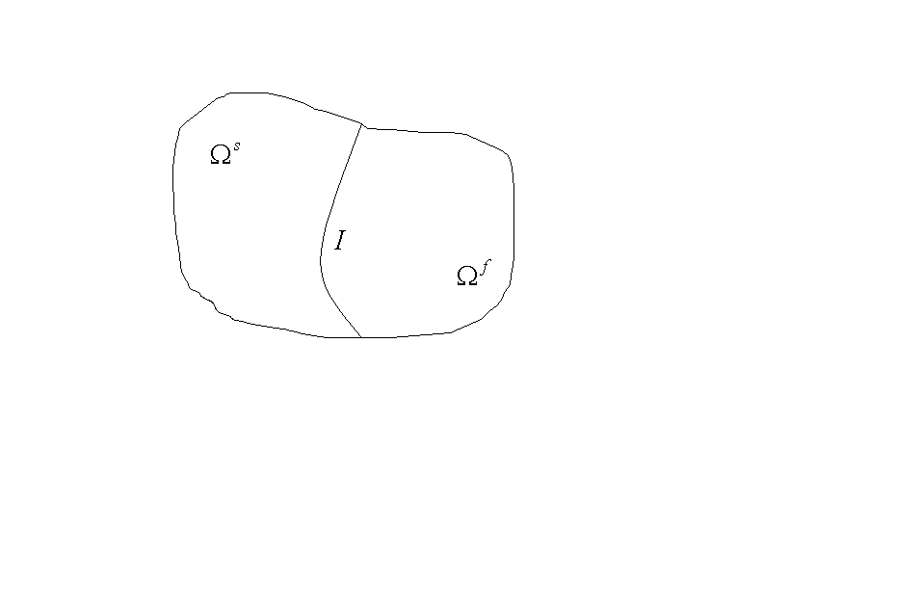

nax. 4.2.1

*I* interfeisze (ix. nax. 4.2.1) vixilavT gadaadgilebebisa da Zabvebis uwyvetobis

 (4.2.12)

pirobas, sadac kvadratuli frCxilebi, Cveulebisamebr, Se­sa­bamisi sidideebis naxtoms aRniSnavs.

Cven ganvixilavT erTgvarovan (Tumca araerTgvarovani pi­robebis ganxilvac SeiZleboda)

 (4.2.13)

sasazRvro da

 (4.2.14)

sawyis pirobebs, sadac .

(4.2.1), (4.2.5), (4.2.12)-(4.2.14) amocanis variaciul for­mu­lirebas aqvs Semdegi saxe:

veZebT  veqtors, rogorc *t*-s funqcias mniSvnelobebiT -Si, iseTs, rom

, (4.2.15)

, (4.2.16)

sadac

 (4.2.17)

*sobolevis[2]*)*  sivrce aris iseTi -ze gan­saz­Rvru­li veqtor-funqciebis simravle, romelTa kompo­nen­tebi , e.i. kvadratSi jamebadia, maTi ganzoga­de­bu­li an ganawilebis azriT warmoebulebic aseve kvadratSi ja­mebadia da maTi kvalebi -ze nulis tolia (ix. da­ma­te­ba 1 da $1.21).

(4.2.15)-is misaRebad (4.2.1) da (4.2.5) unda CavweroT, (4.2.17)-is gamoyenebiT, erTiani saxiT -ze; am ukanas­kne­lis orive mxare gavamravloT -ze; miRebuli vain­tegroT -ze da -is Semcvel wevrSi movaxdinoT na­wilobiTi integreba, imis gaTvaliswinebiT, rom  fun­qcie­bis kvali -ze nulis tolia. -is simet­riu­lo­bis gamo cxadia, rom



 (4.2.18)

da, amdenad, (4.2.15)-Si -is nacvlad SeiZleba  Cav­svaT.

Tu (4.2.11)-s CavsvamT (4.2.6)-Si, maSin calsaxad ga­ni­sazRvreba -sa da misi warmoebulebis saSualebiT. Tu mxed­velobaSi miviRebT (4.2.18)-s, advili sanaxavia, rom



, (4.2.19)

sadac

,

,





radganac



.

**SeniSvna 4.2.1**. cxadia, *a* da *b* ar arian -ze koer­ci­tiulebi. Tumca maTi jami koercitiulia, e.i.  iseTi, rom

. (4.2.20)

marTlac, (4.2.7) da (4.2.4)-dan gamomdinareobs, rom



da amis Semdeg (4.2.20) SeiZleba ise damtkicdes rogorc le­ma 1.2 [56]-is VI TavSi.

**SeniSvna 4.2.2**. (4.2.3), (4.2.4) da (4.2.7) pirobebSi (4.2.15) sawyis-sasazRvro amocanas aqvs erTaderTi amo­nax­sni, iseTi, rom

.

rac imas niSnavs, rom rogorc *t*-s funqciebi



da yoveli maTgani fiqsirebuli -sTvis iRebs mniS­­vnelobebs, romlebic -s ekuTvnian.

1. *) d. bernuli (1700-1782).
2. *) s.l. sobolevi (1908-1988).